<https://www.youtube.com/watch?v=sDv4f4s2SB8&list=PLblh5JKOoLUICTaGLRoHQDuF_7q2GfuJF&index=47>



Today we're gonna learn about gradient descent and we're gonna go through the algorithm step by step.

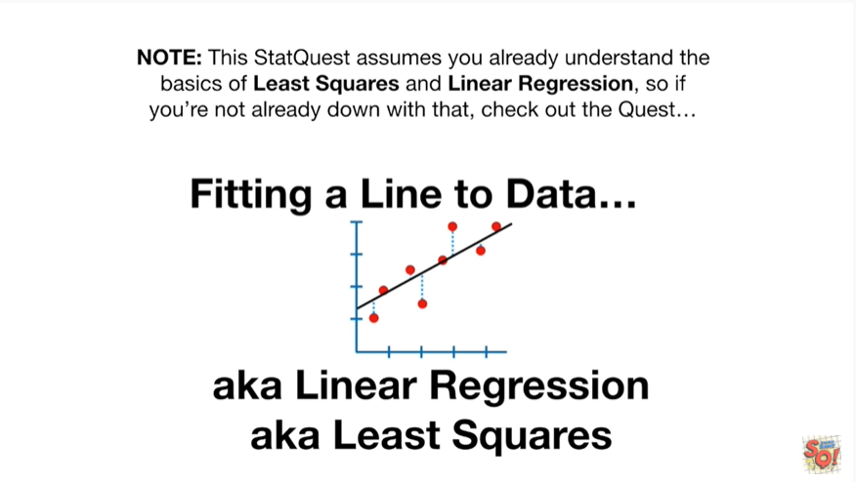

Note : this stat quest assumes you already understand the basics of least squares and linear regression.

So if you're not already down with that, check out the quest.

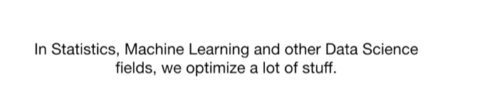

In statistics machine learning and other data science fields we optimize a lot of stuff.

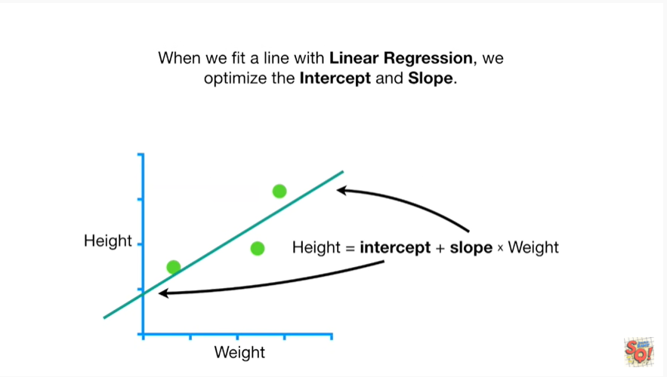

When we fit a line with linear regression, we optimize the intercept and the slope.

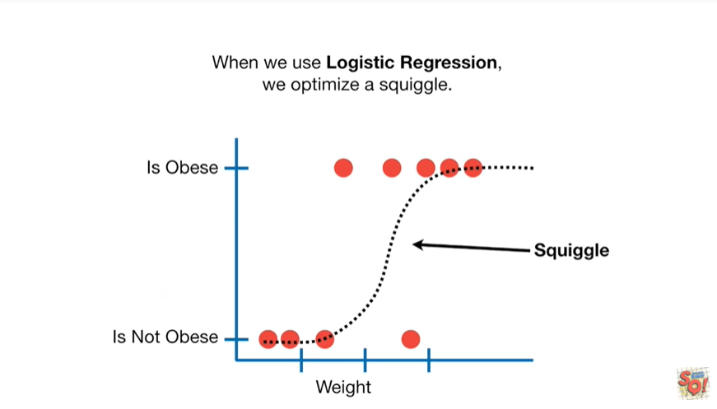

When we use logistic regression, we optimize a squiggle.

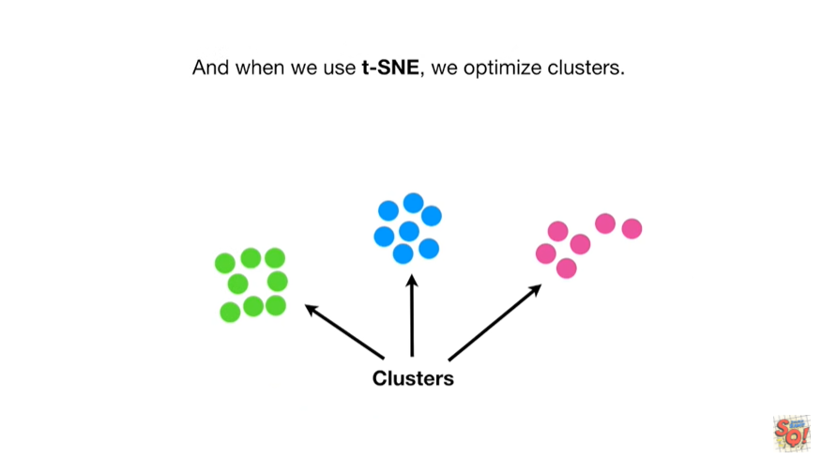

And when we use T Snee we optimize clusters.

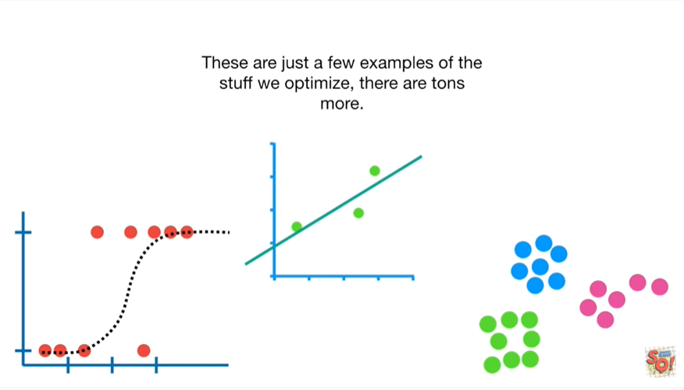

These are just a few examples of the stuff we optimize there are tons more.

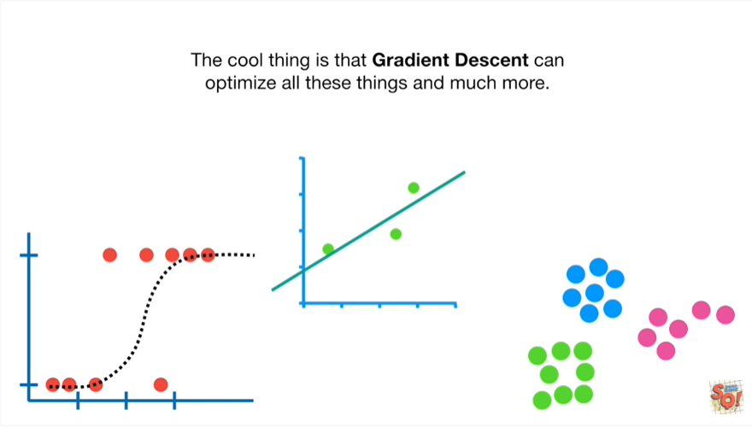

The cool thing is that gradient descent can optimize all these things and much more.

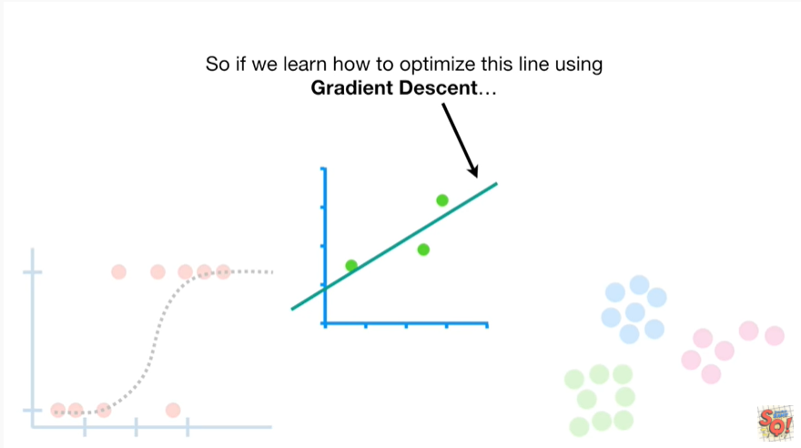

So if we learn how to optimize this line using gradient descent

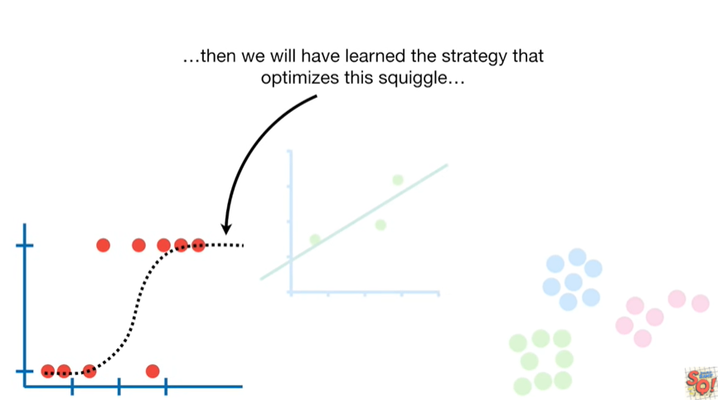

then we'll have learned the strategy that optimizes this squiggle

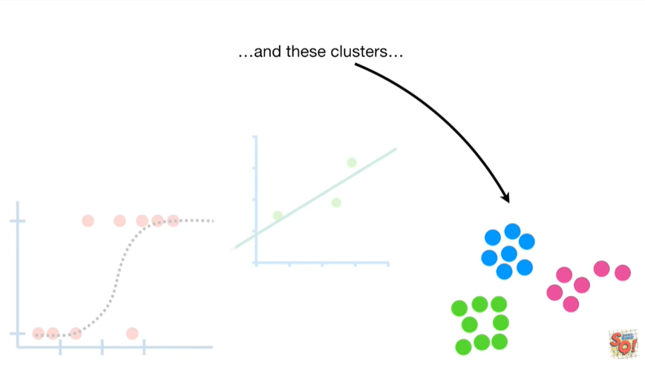

and these clusters

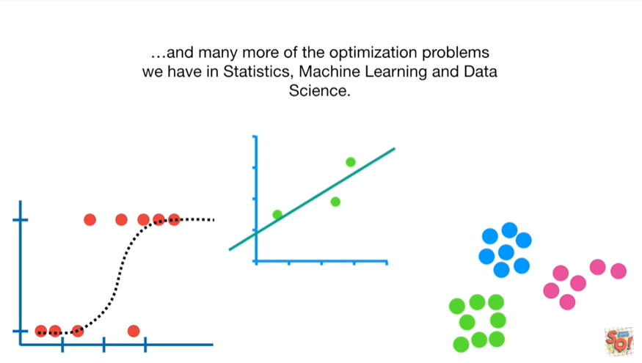

and many more of the optimization problems we have in statistics, machine learning and data science.

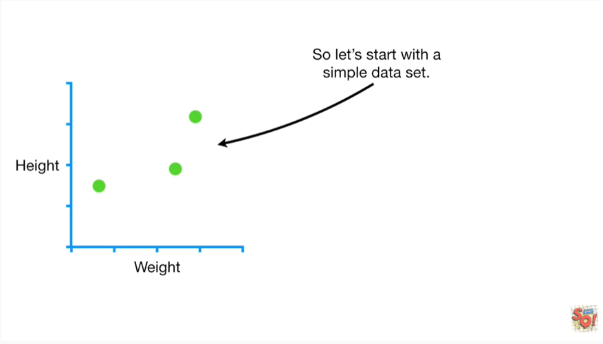

So let's start with a simple data set.

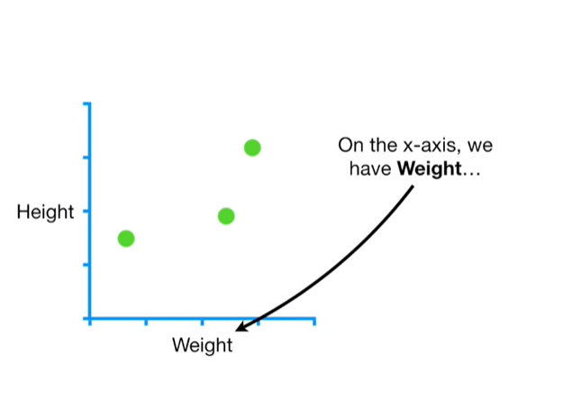

On the x-axis we have weight

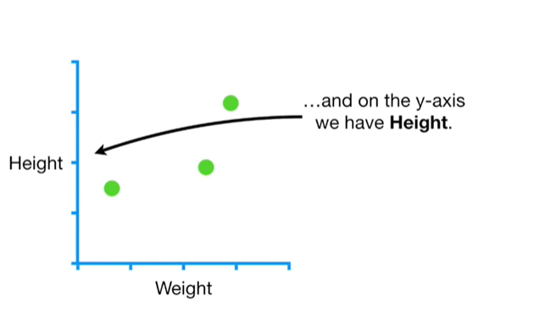

and on the y axis we have height.

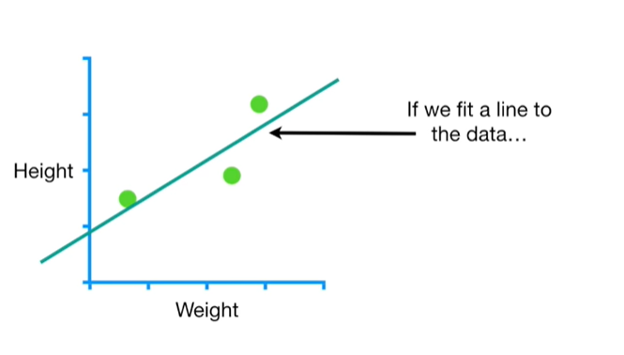

If we fit a line to the data

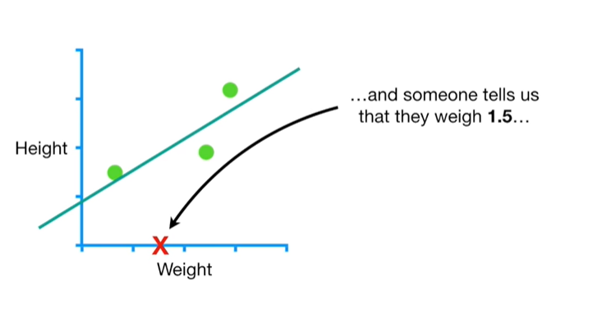

and someone tells us that they weigh 1.5

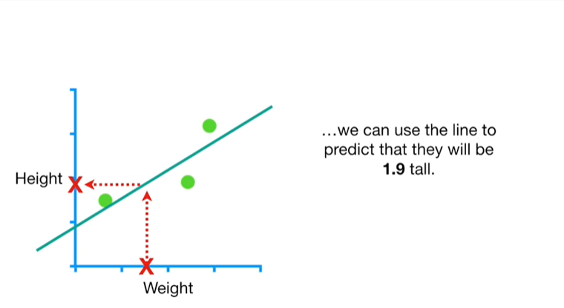

we can use the line to predict that they will be 1.9 tall.

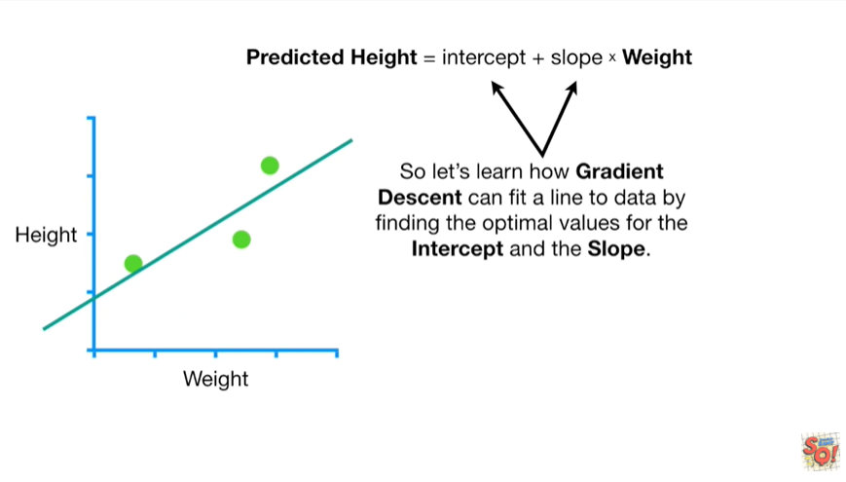

So let's learn how gradient descent can fit a line to data by finding the optimal values for the intercept and the slope.

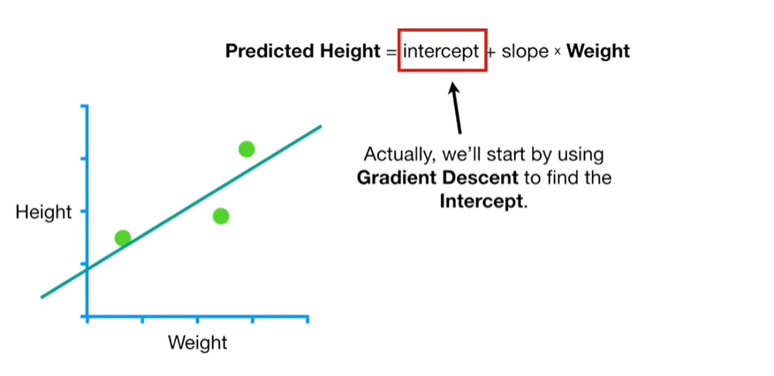

Actually, we'll start by using gradient descent to find the intercept.

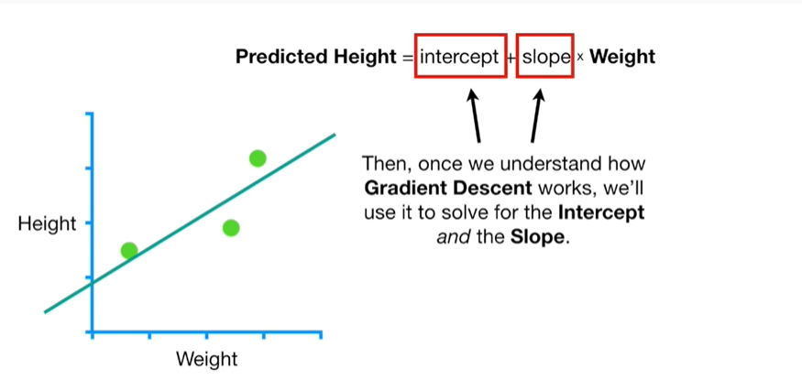

Then, once we understand how gradient descent works, we'll use it to solve for the intercept and the slope.

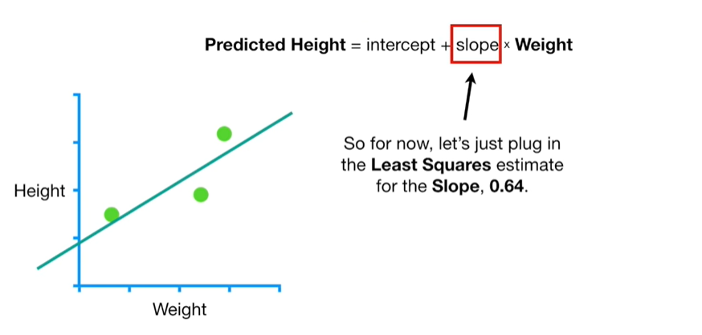

So for now, let's just plug in the least squares estimate for the slope,

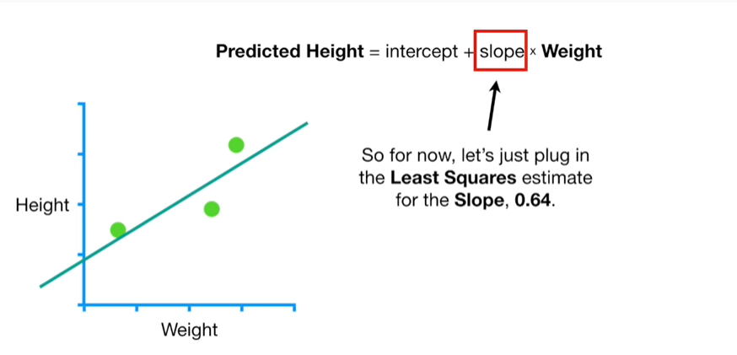

0.64.

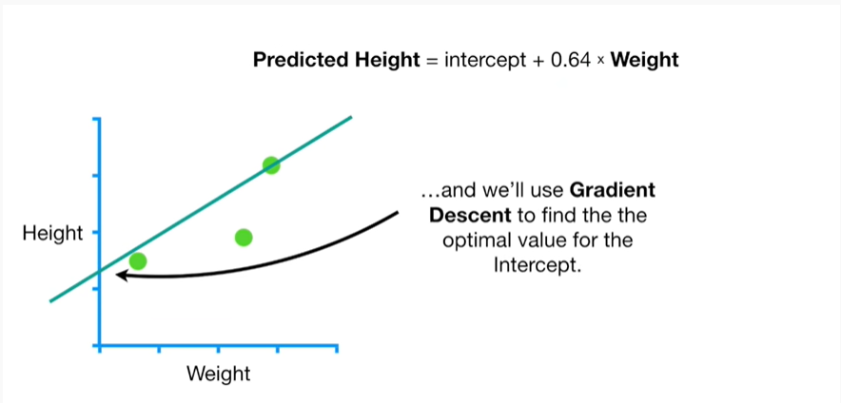

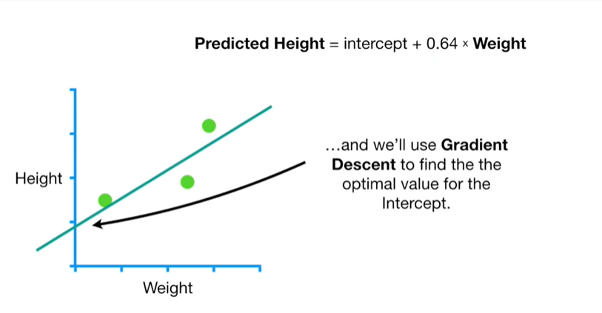

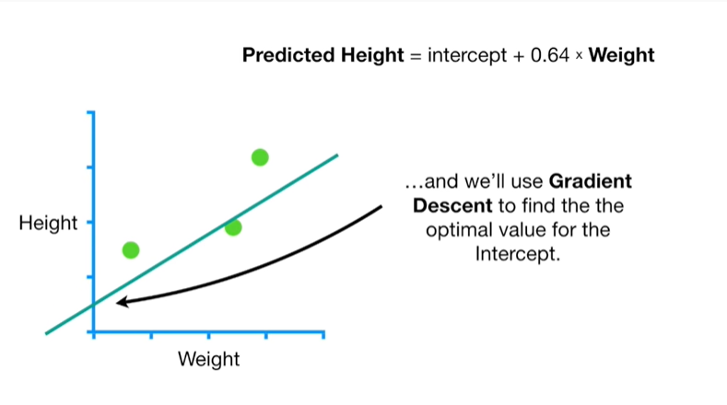

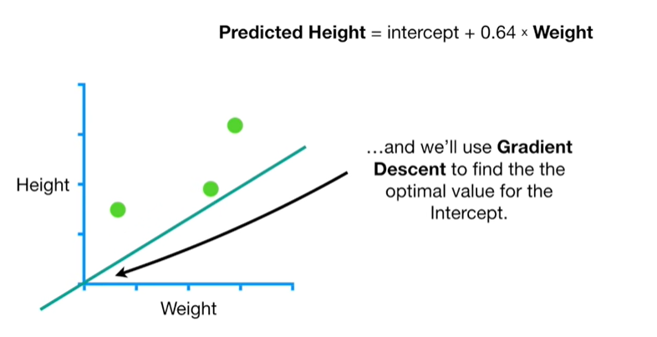

And we'll use gradient descent to find the optimal value for the intercept.

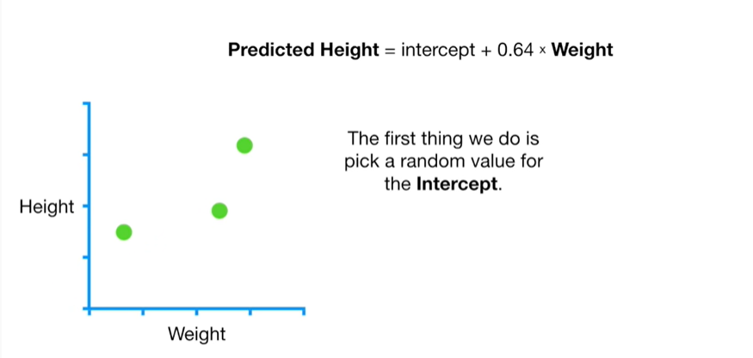

The first thing we do is pick a random value for the intercept.

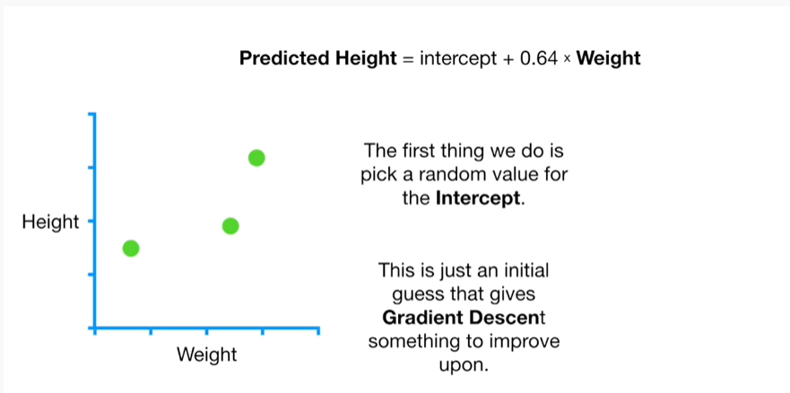

This is just an initial guess that gives gradient descent something to improve upon.

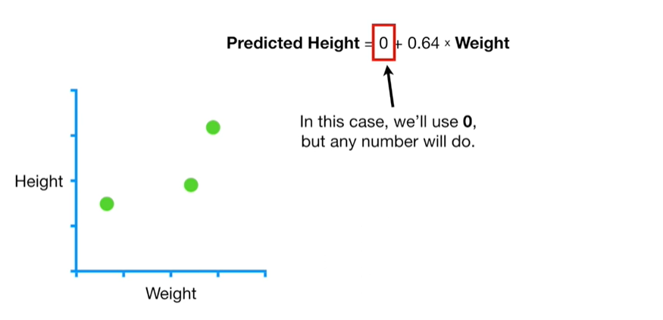

In this case, we'll use zero, but any number will do.

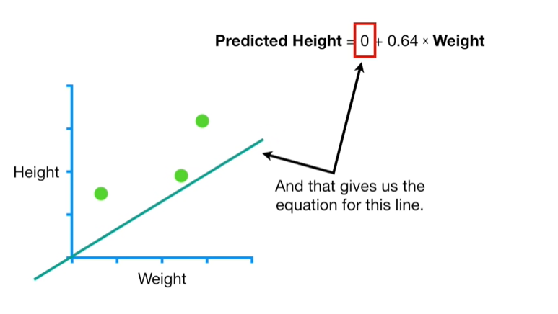

And that gives us the equation for this line.

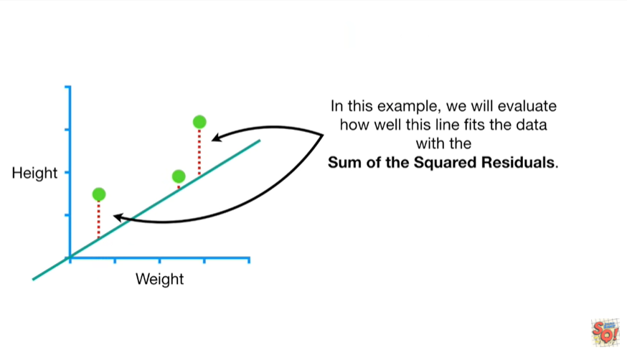

In this example, we will evaluate how well this line fits the data with the sum of the squared residuals.

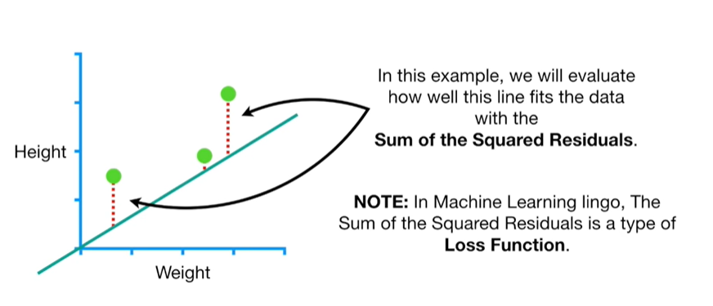

Note : in machine learning lingo the sum of the squared residuals is a type of loss function.

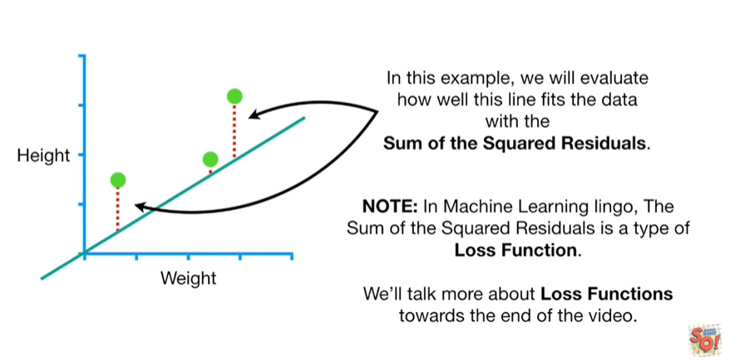

We'll talk more about loss functions towards the end of the video.

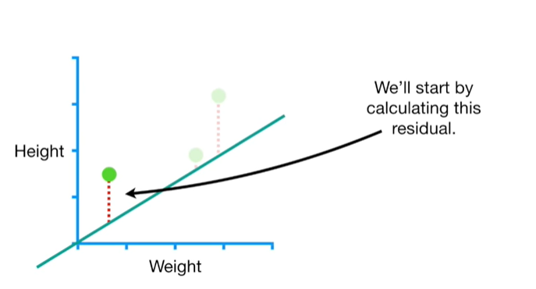

We'll start by calculating this residual.

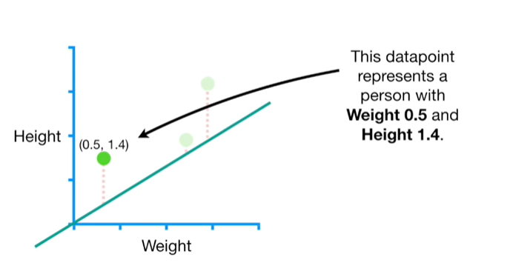

This data point represents a person with weight zero point five and height one point four.

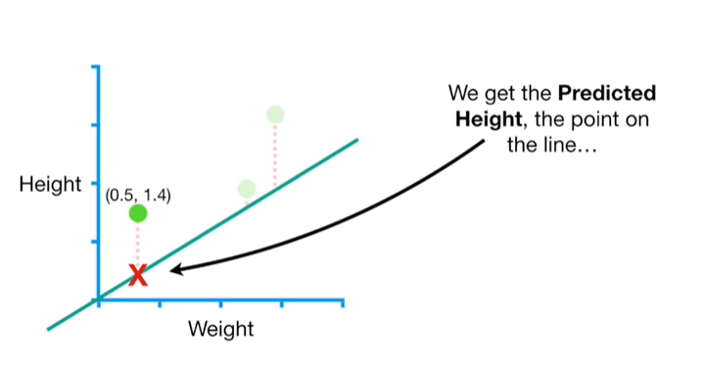

We get the predicted height, the point on the line

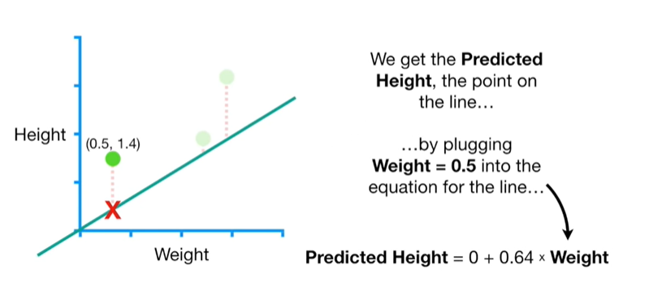

by plugging weight equals zero point five into the equation for the line

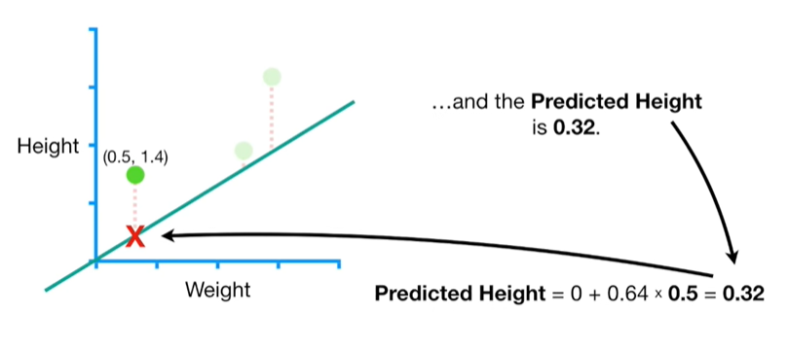

and the predicted height is 0.32.

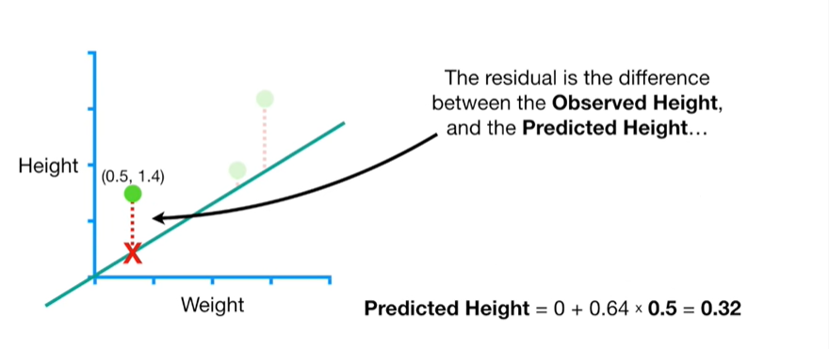

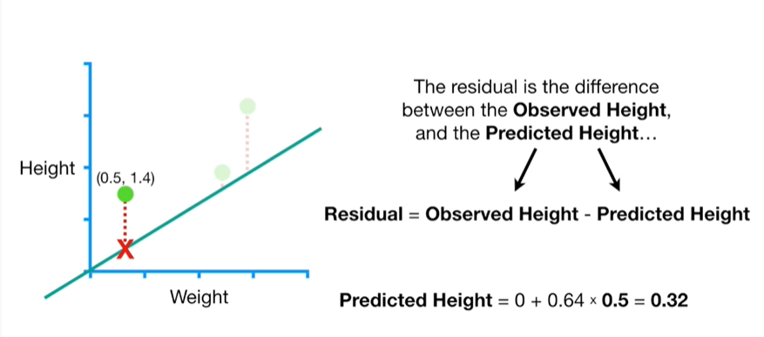

The residual is the difference between the observed height and the predicted height

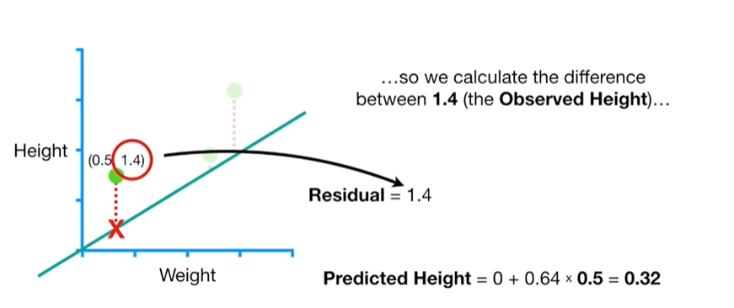

so we calculate the difference between 1.4

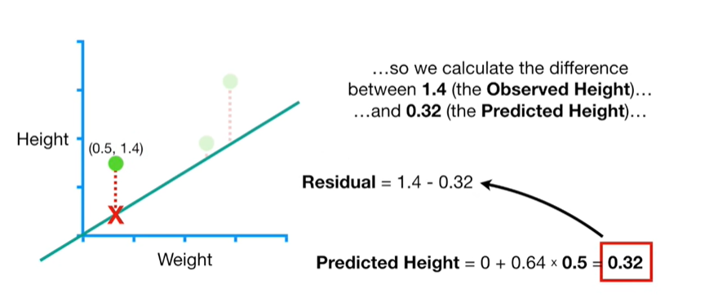

and 0.32

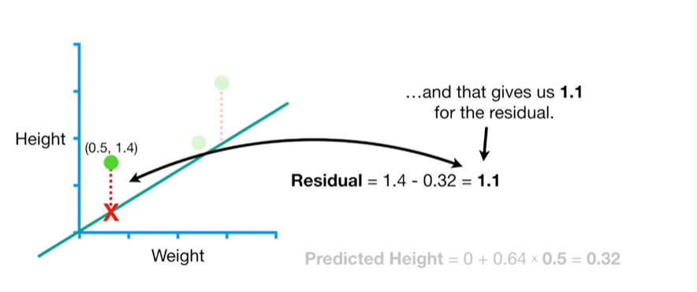

and that gives us 1.1 for the residual.

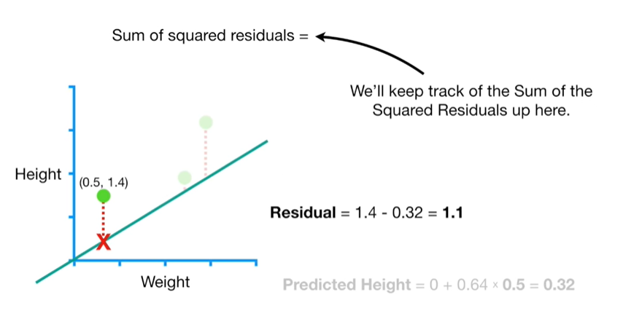

We'll keep track of the sum of the squared residuals up here.

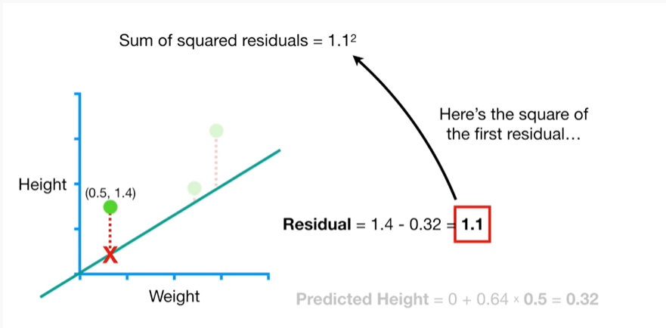

Here's the square of the first residual.

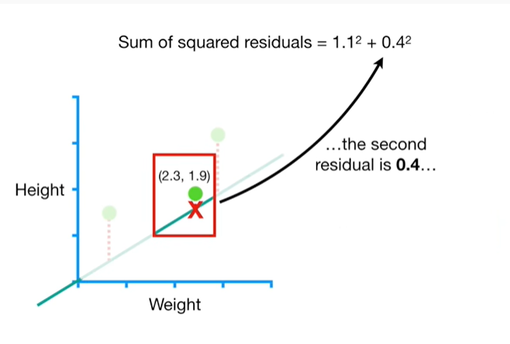

The second residual is 0.4

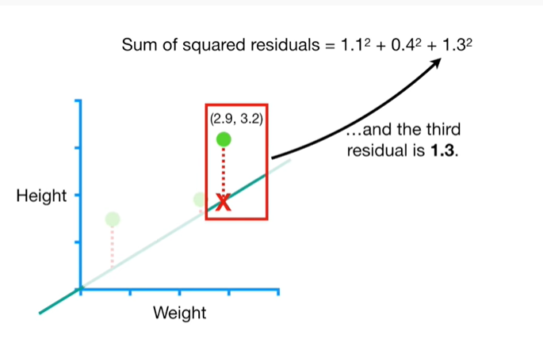

and the third residual is 1.3.

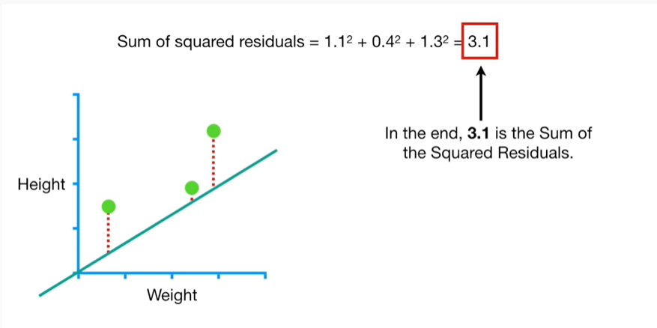

In the end, 3.1 is the sum of the squared residuals.

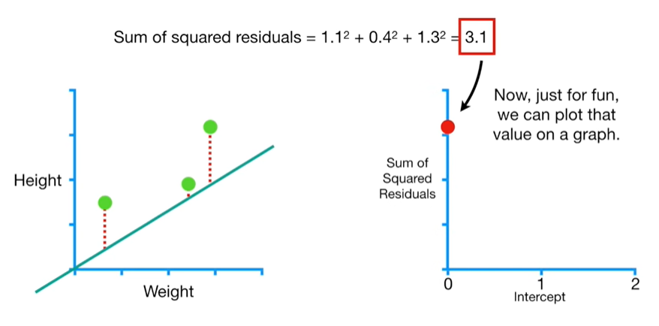

Now just for fun we can plot that value on a graph.

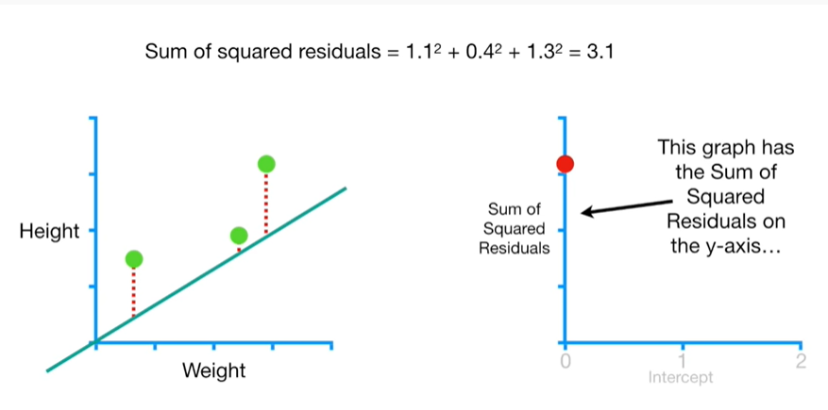

This graph has the sum of squared residuals on the y-axis

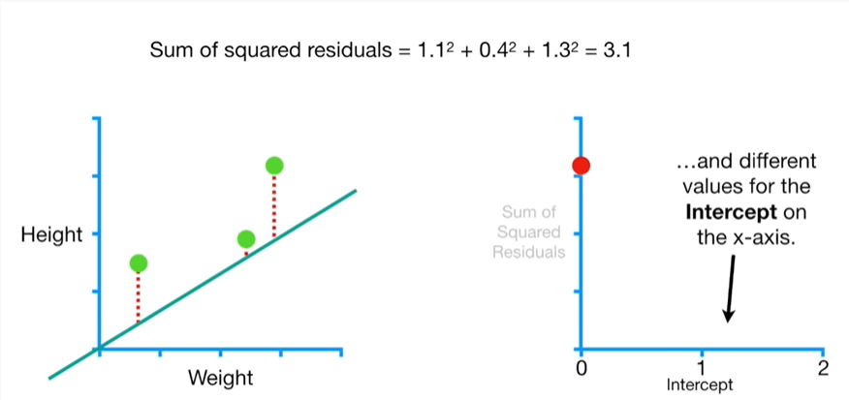

and different values for the intercept on the x-axis.

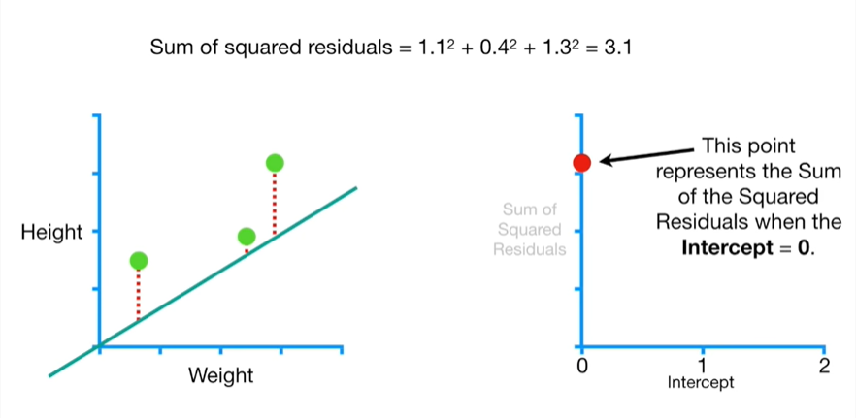

This point represents the sum of the squared residuals when the intercept equals zero.

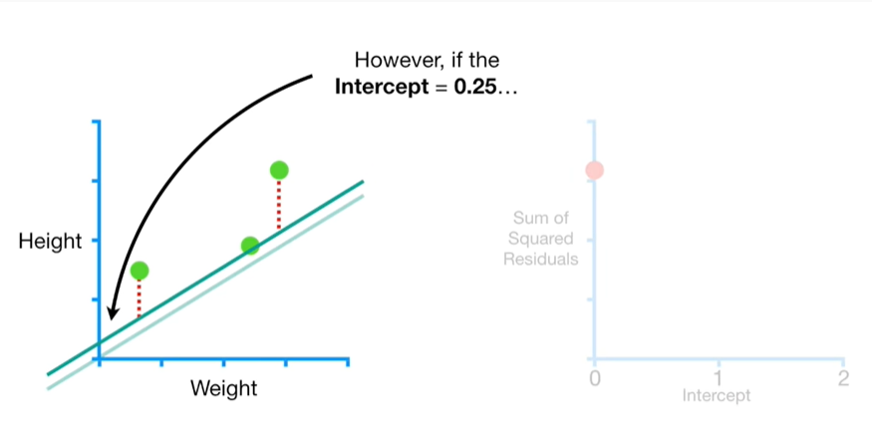

However, if the intercept equals 0.25

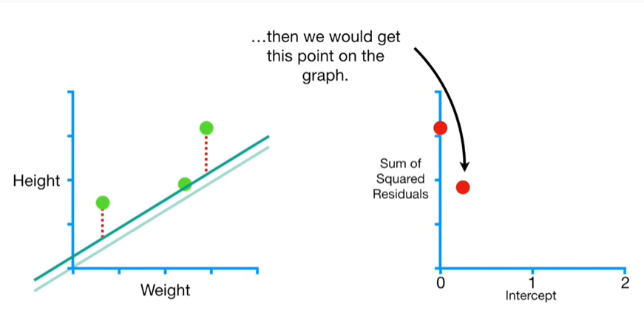

then we would get this point on the graph.

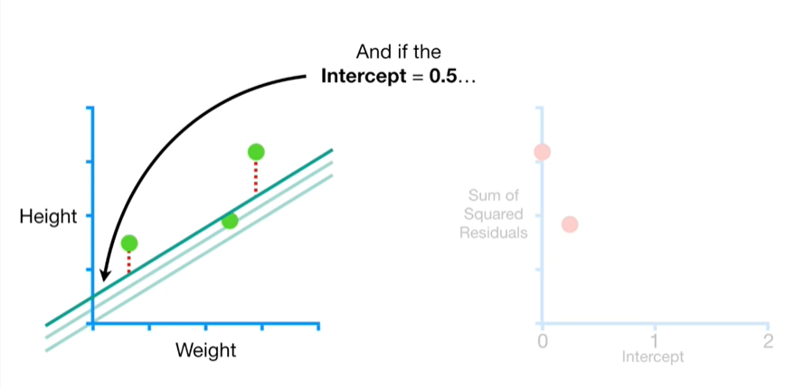

And if the intercept equals 0.5

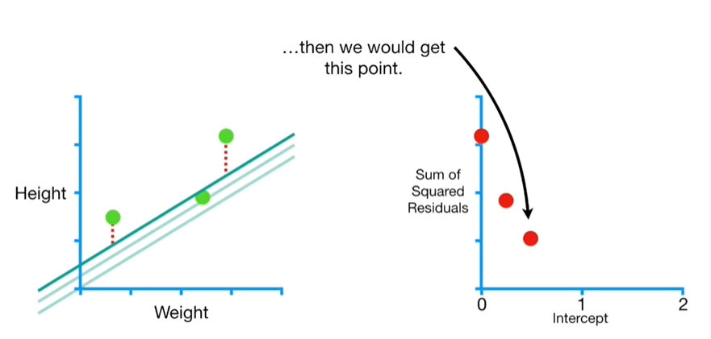

then we would get this point.

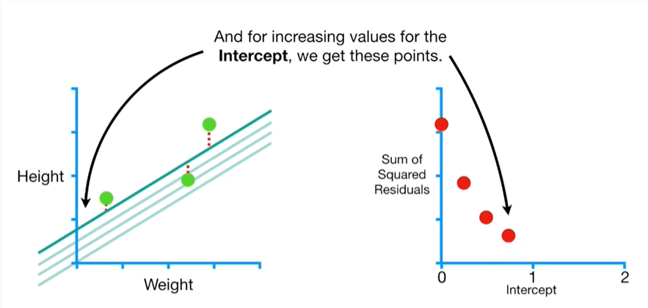

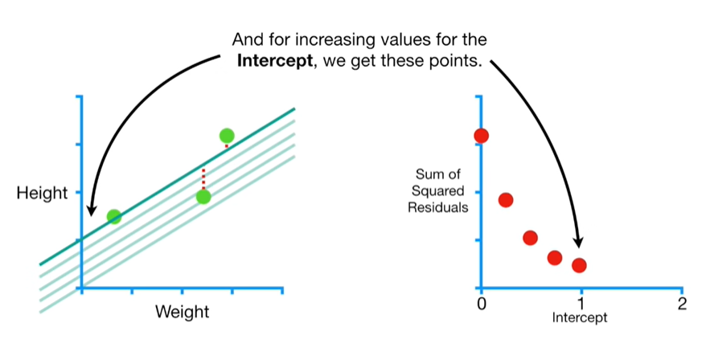

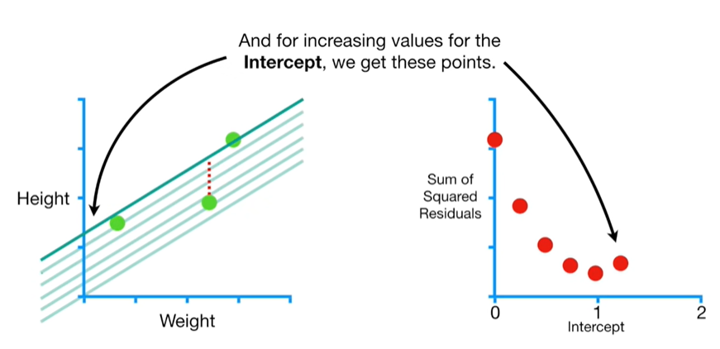

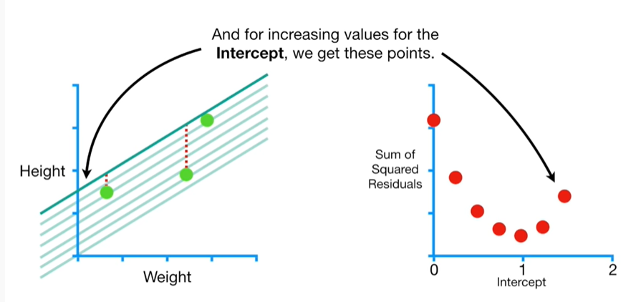

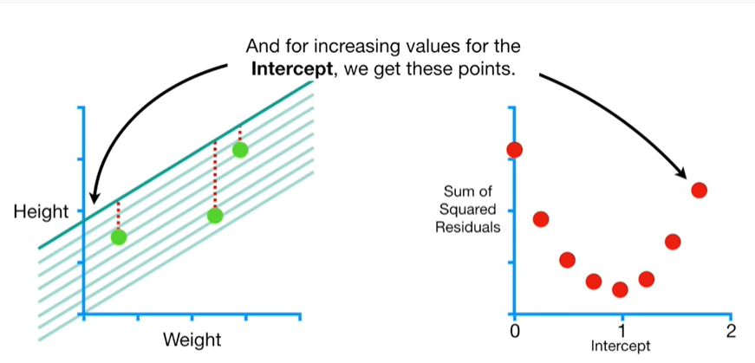

And for increasing values for the intercept we get these points.

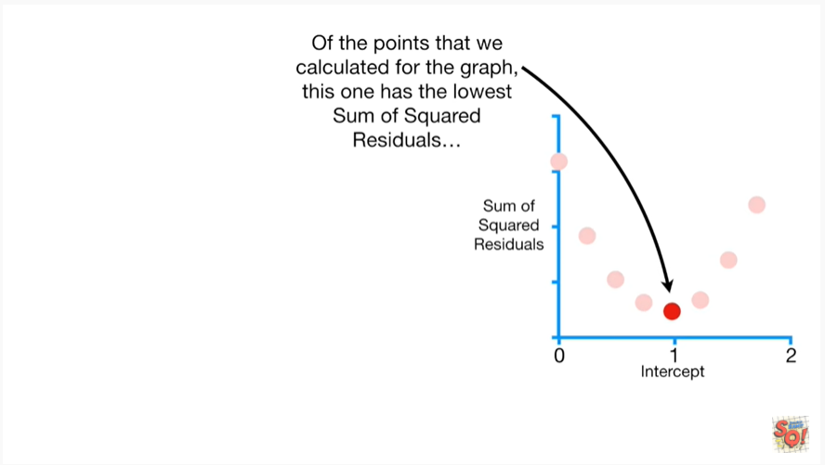

Of the points that we calculated for the graph, this one has the lowest sum of squared residuals.

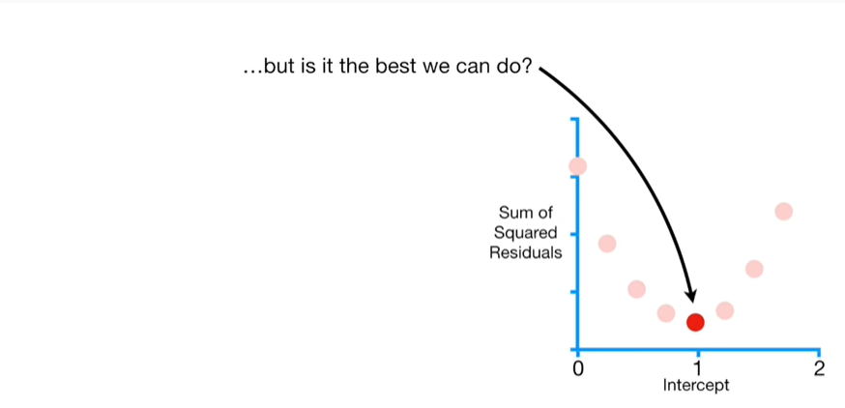

But is it the best we can do ?

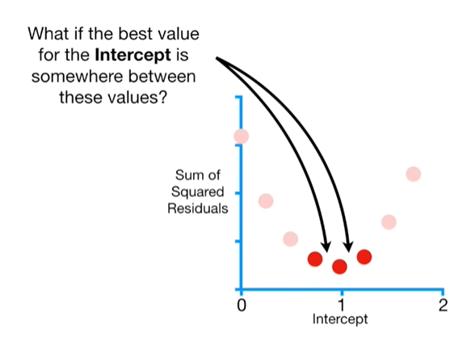

What if the best value for the intercept is somewhere between these values ?

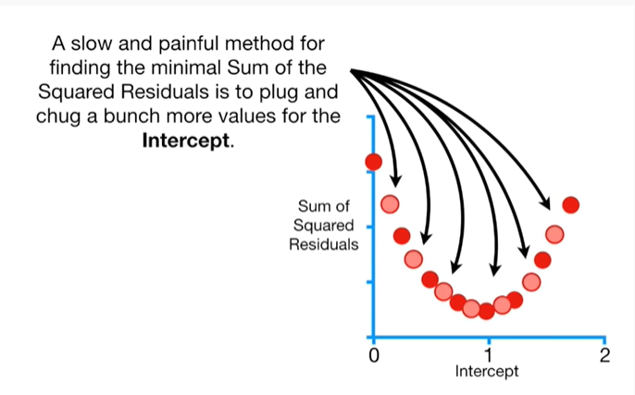

A slow and painful method for finding the minimal sum of the squared residuals is to plug and chug a bunch more values for the intercept.

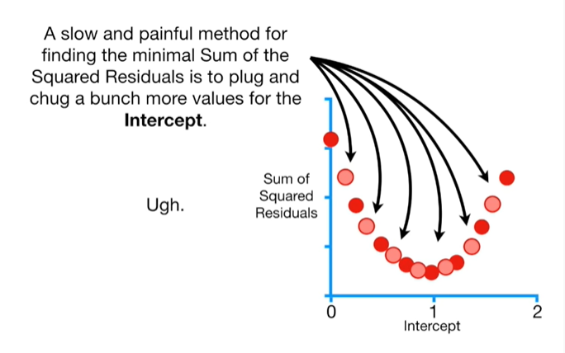

Ugh.

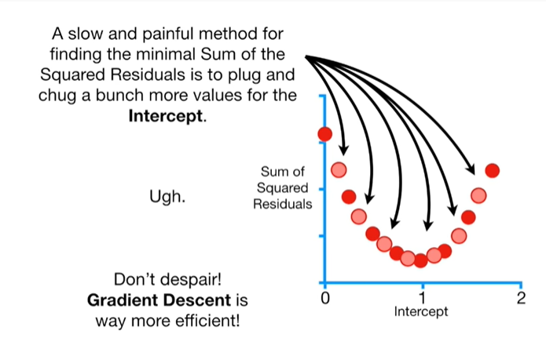

Don't despair gradient descent is way more efficient.

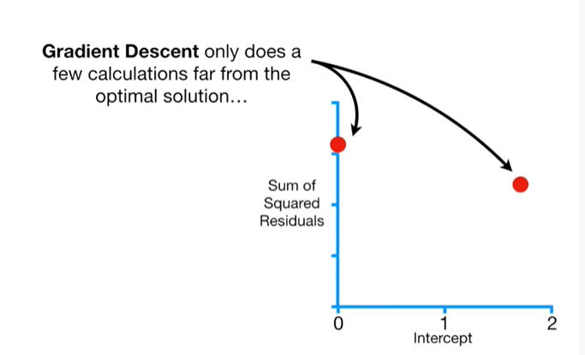

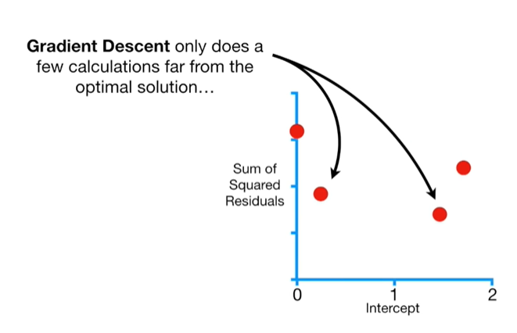

Gradient descent only does a few calculations far from the optimal solution

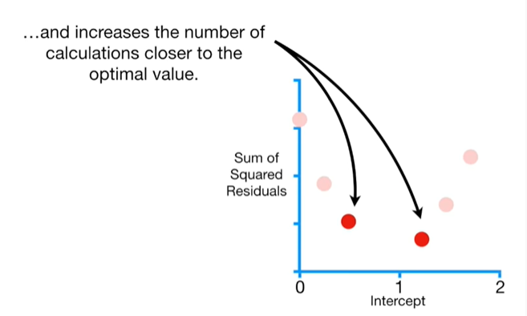

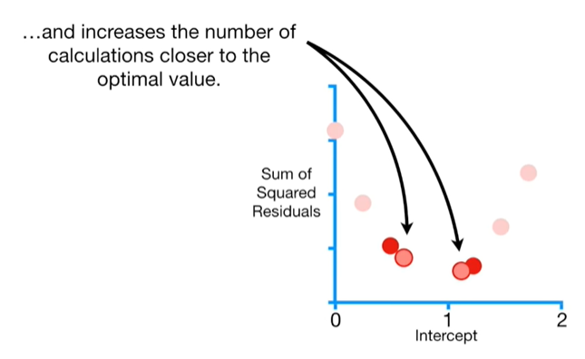

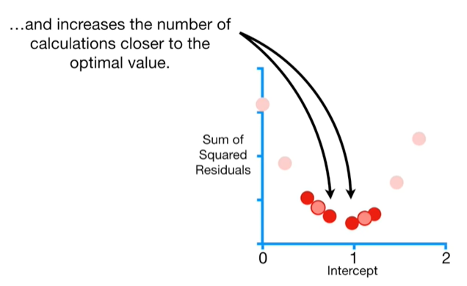

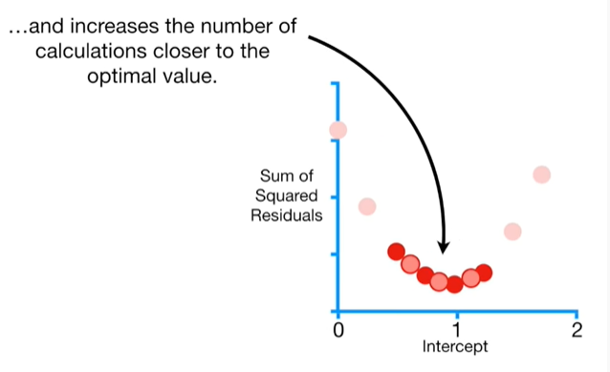

and increases the number of calculations closer to the optimal value.

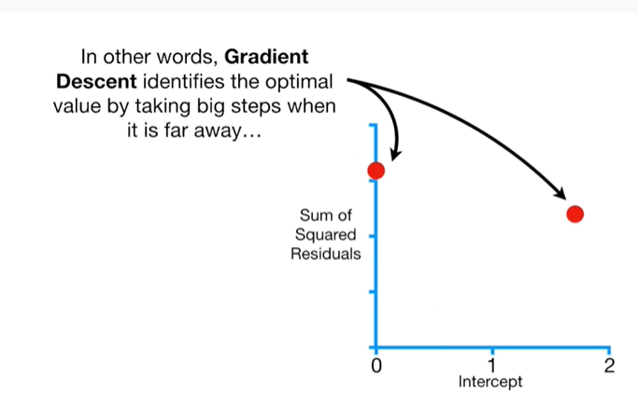

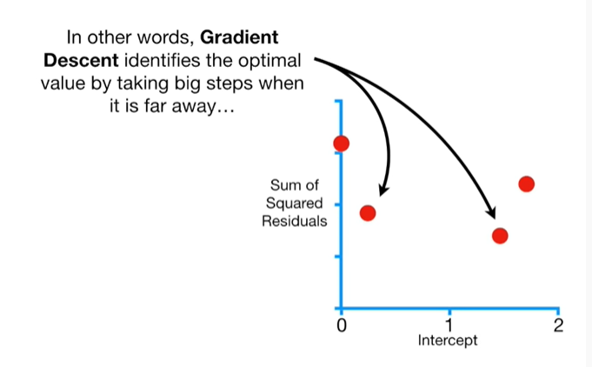

In other words gradient descent identifies the optimal value by taking big steps when it is far away

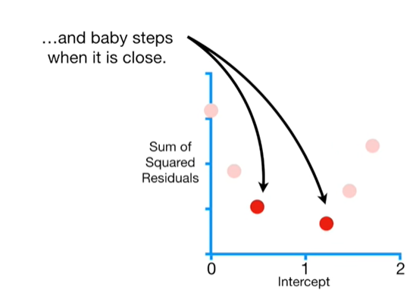

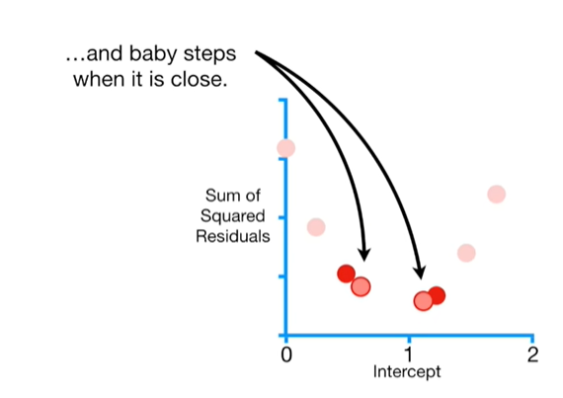

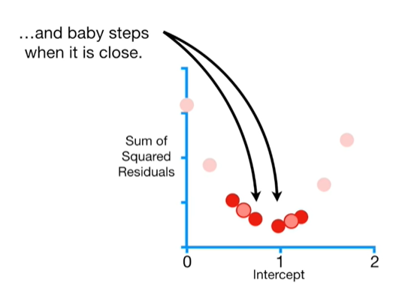

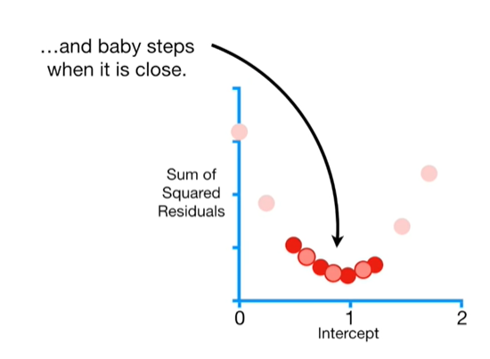

and baby steps when it is close.

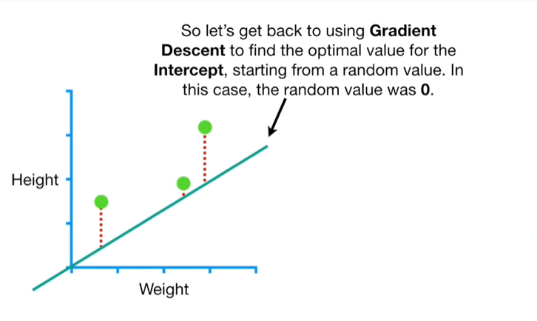

So let's get back to using gradient descent to find the optimal value for the intercept, starting from a random value.

In this case, the random value was 0.

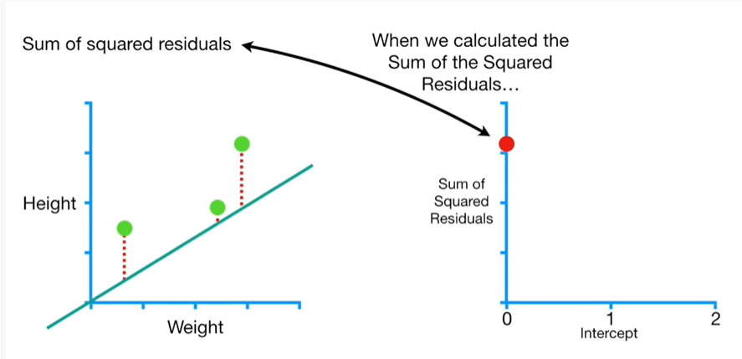

When we calculated the sum of the squared residuals

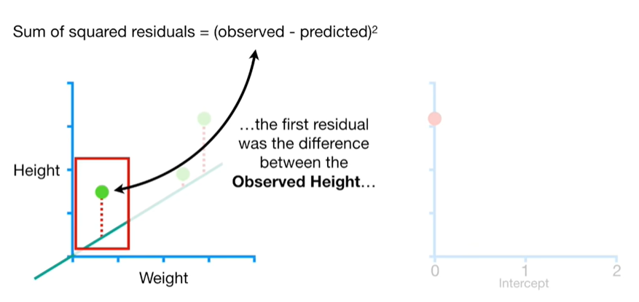

the first residual was the difference between the observed height

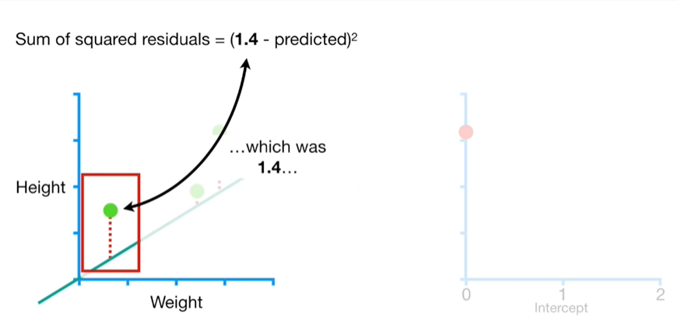

which was 1.4

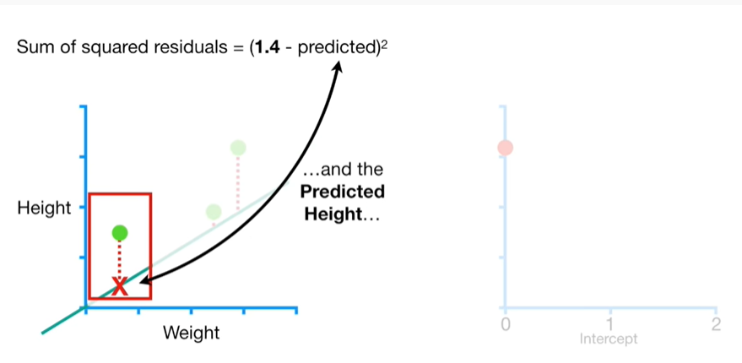

and the predicted height

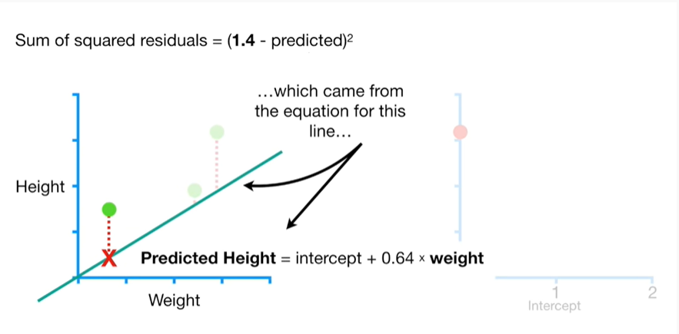

which came from the equation for this line

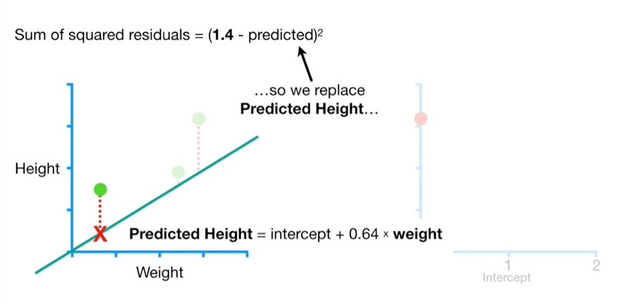

so we replaced predicted height

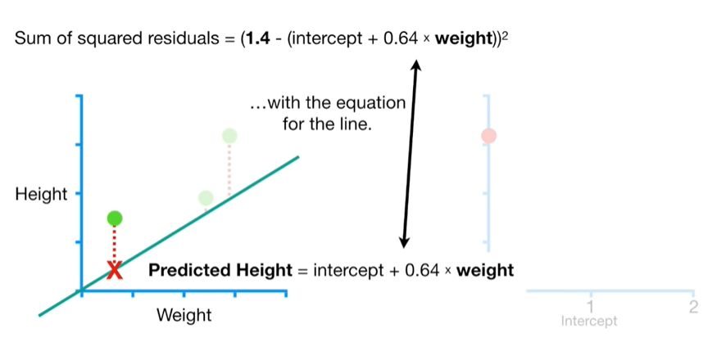

with the equation for the line.

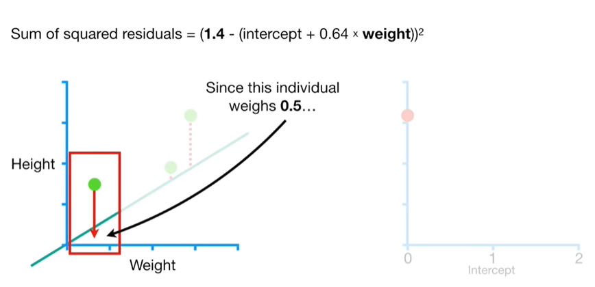

Since the individual weighs 0.5

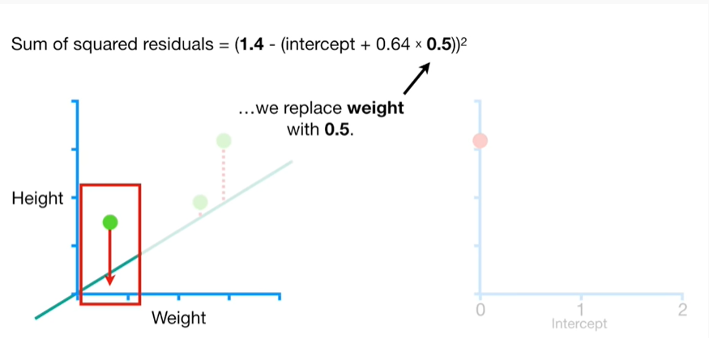

we replace weight with 0.5.

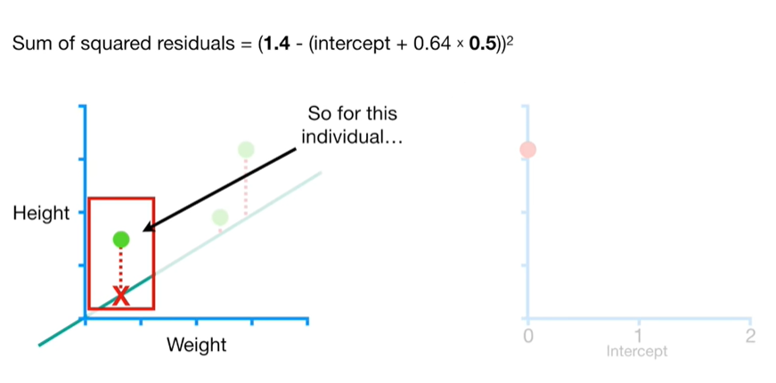

So for this individual

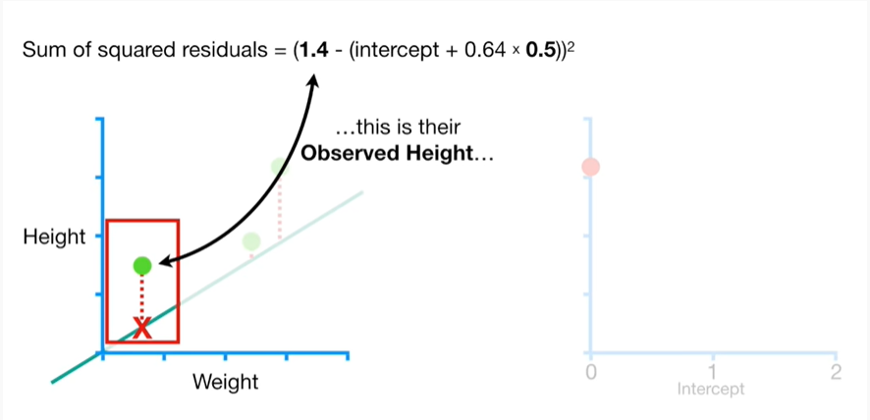

this is their observed height

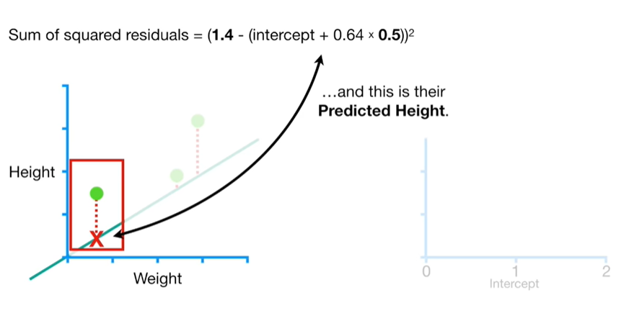

and this is their predicted height.

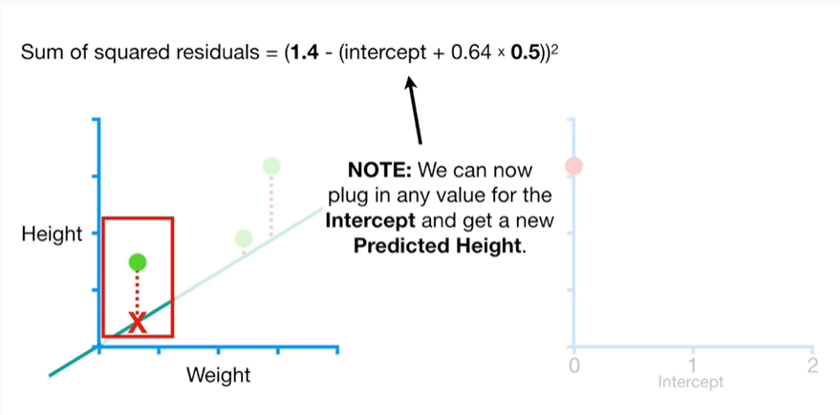

Note : we can now plug in any value for the intercept and get a new predicted height.

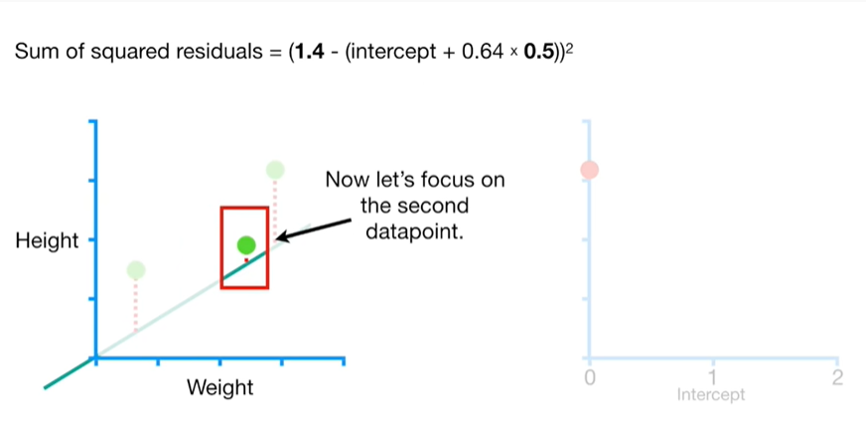

Now let's focus on the second data point.

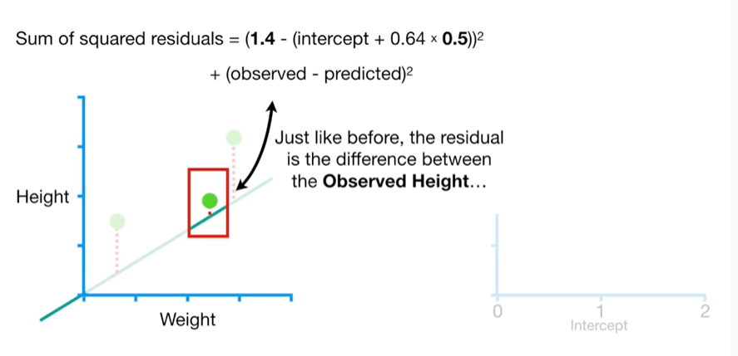

Just like before, the residual is the difference between the observed height

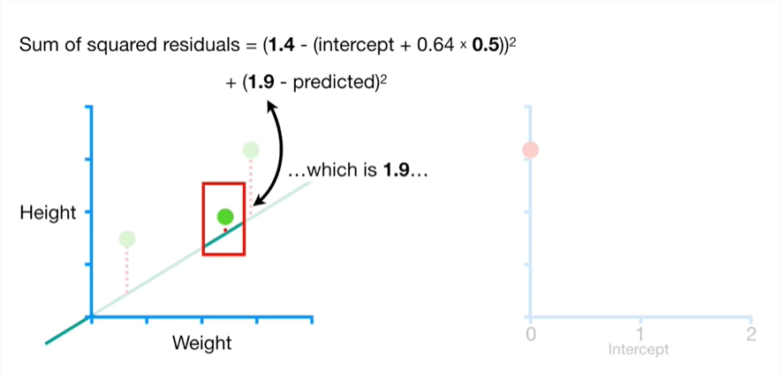

which is 1.9

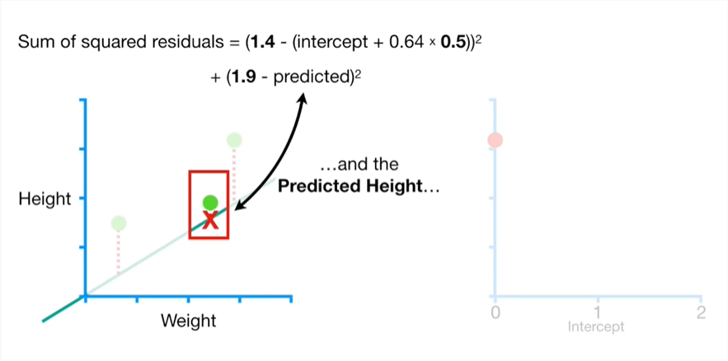

and the predicted height

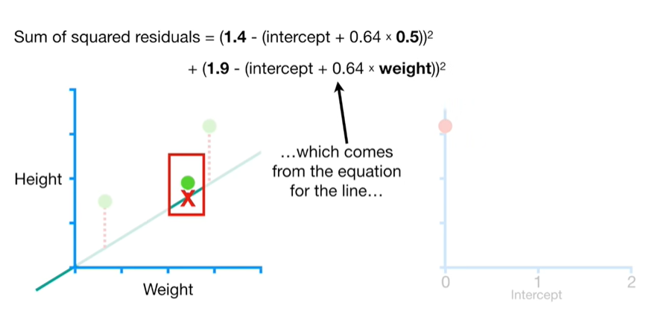

which comes from the equation for the line

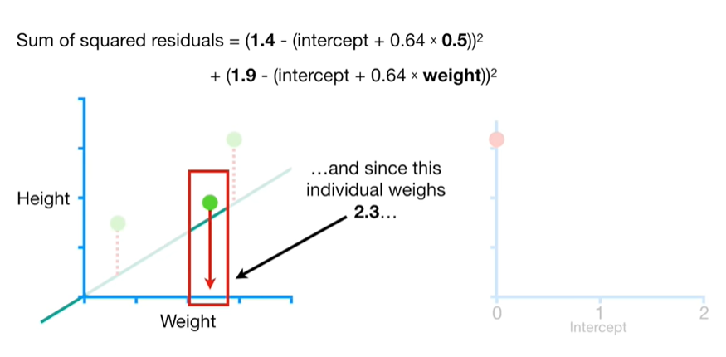

and since this individual weighs 2 point 3

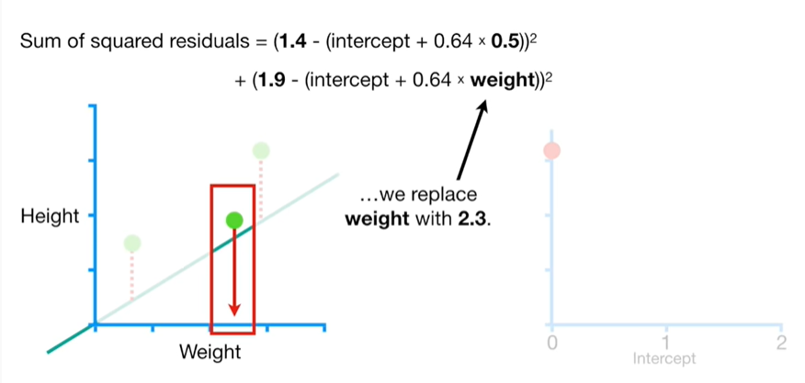

we replace weight with 2.3.

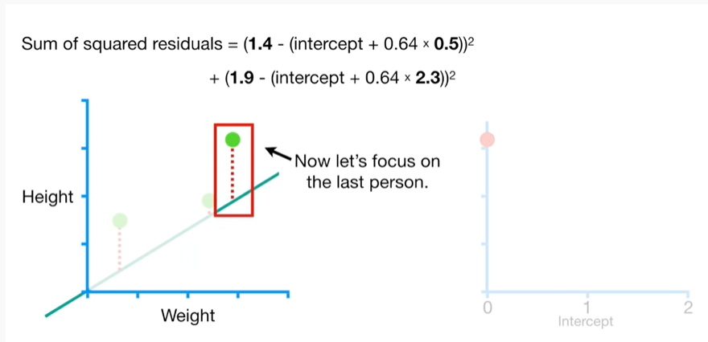

Now let's focus on the last person.

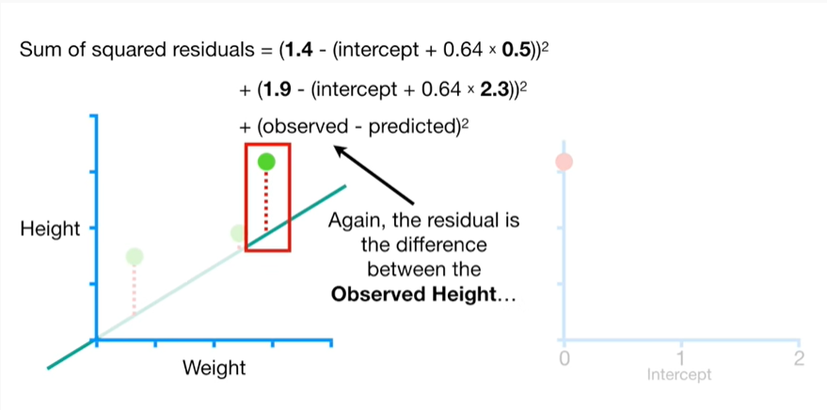

Again, the residual is the difference between the observed height

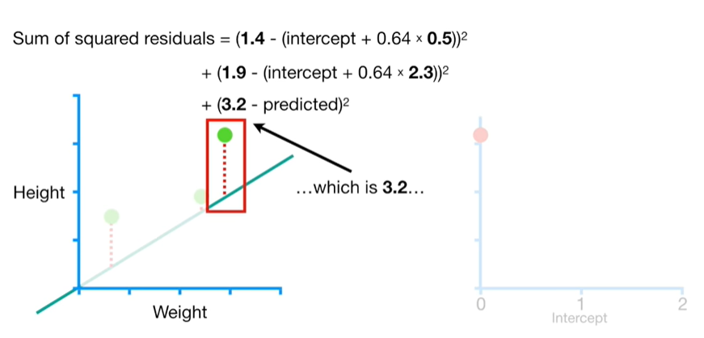

which is 3.2

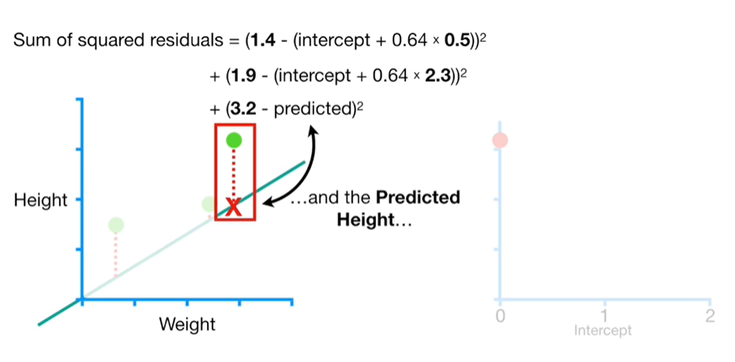

and the predicted height

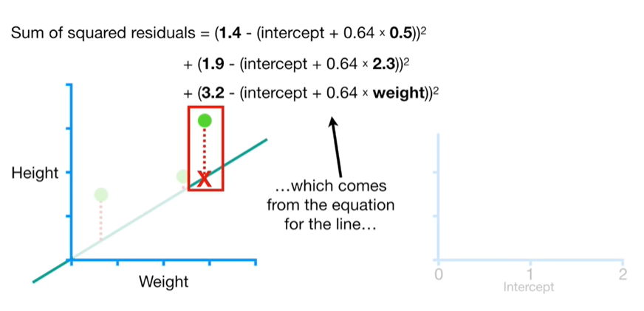

which comes from the equation for the line

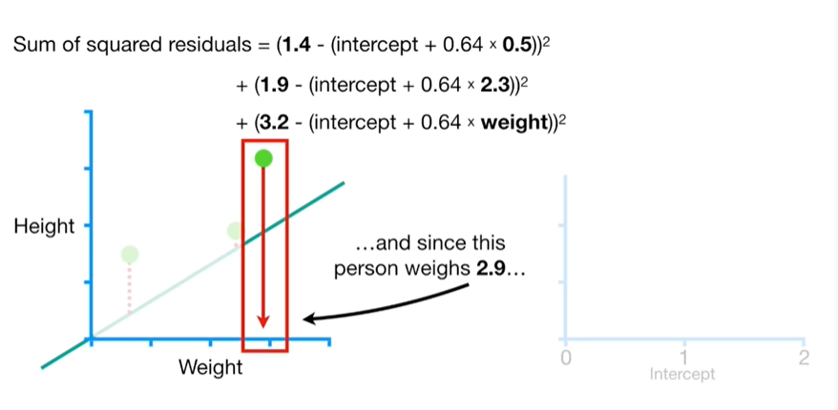

and since this person weighs 2.9

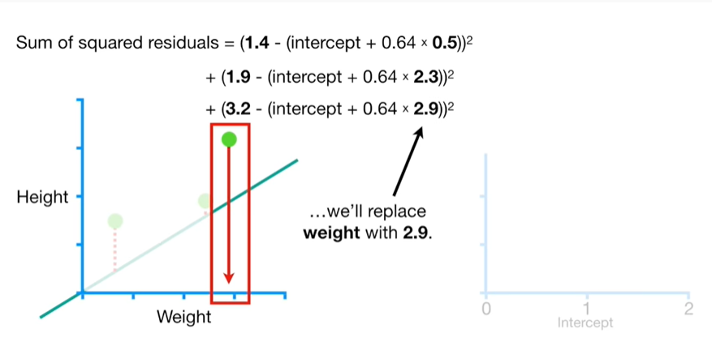

we will replace weight with 2.9.

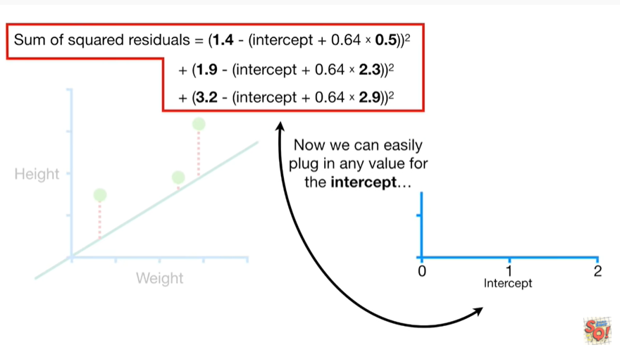

Now we can easily plug in any value for the intercept

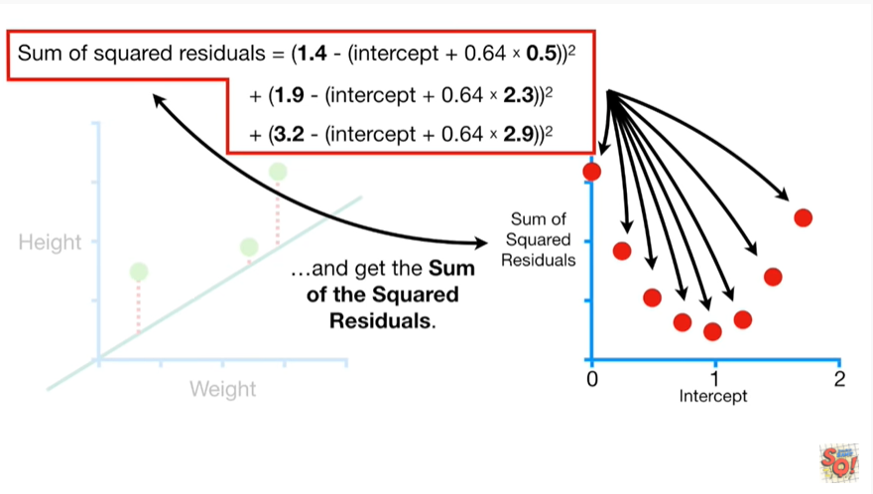

and get the sum of the squared residuals.

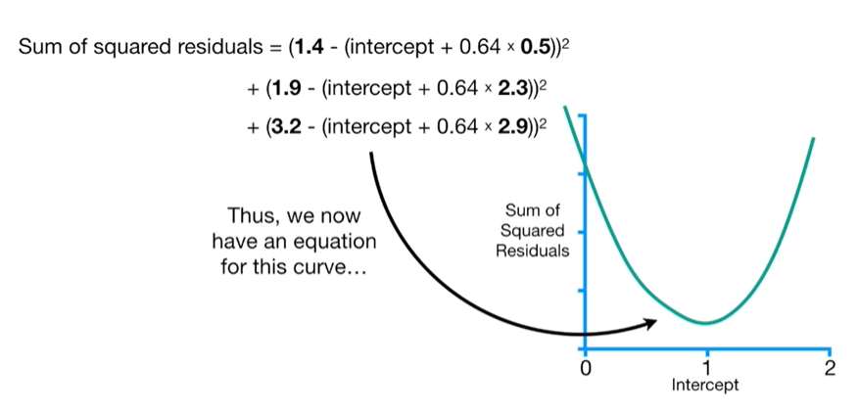

Thus, we now have an equation for this curve

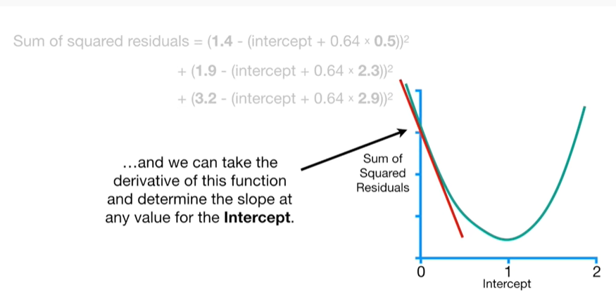

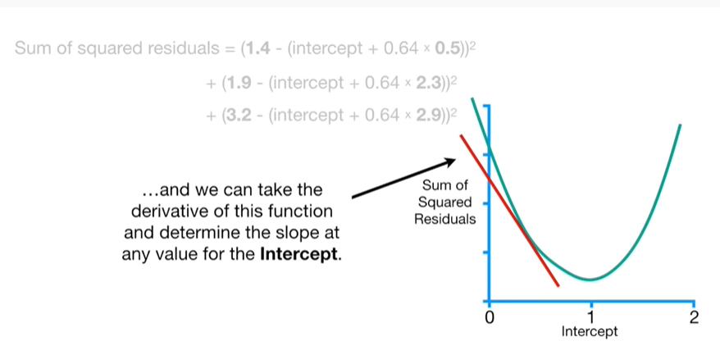

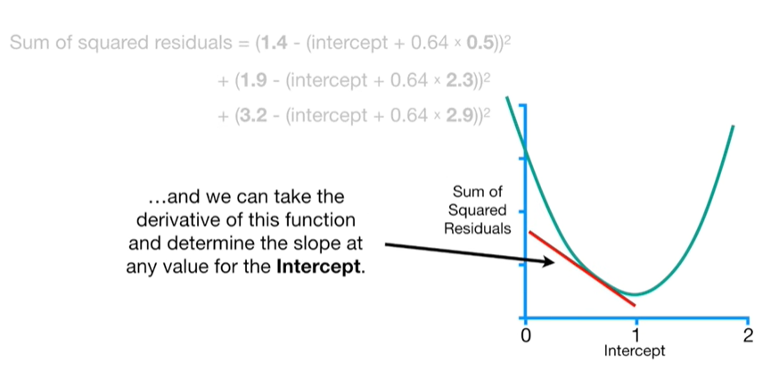

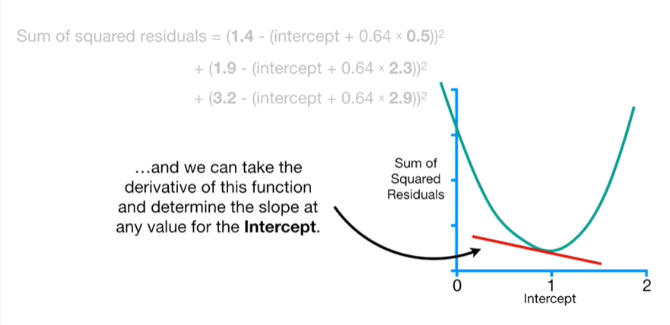

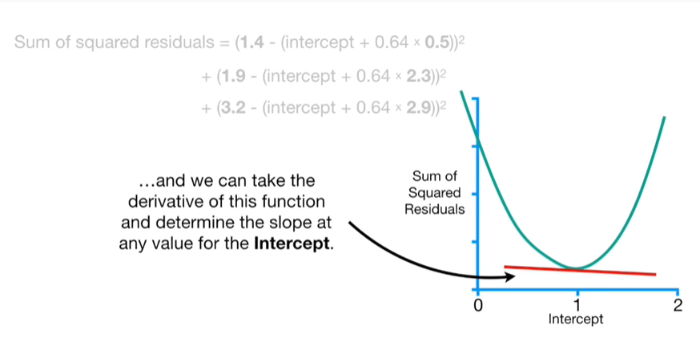

and we can take the derivative of this function and determine the slope at any value for the intercept.

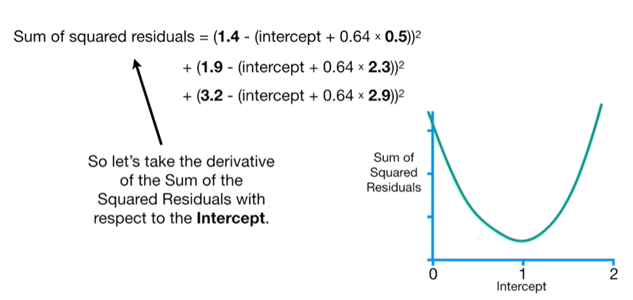

So let's take the derivative of the sum of the squared residuals with respect to the intercept.

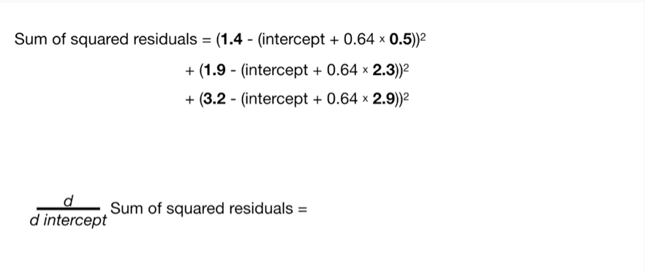

The derivative of the sum of the squared residuals with respect to the intercept equals

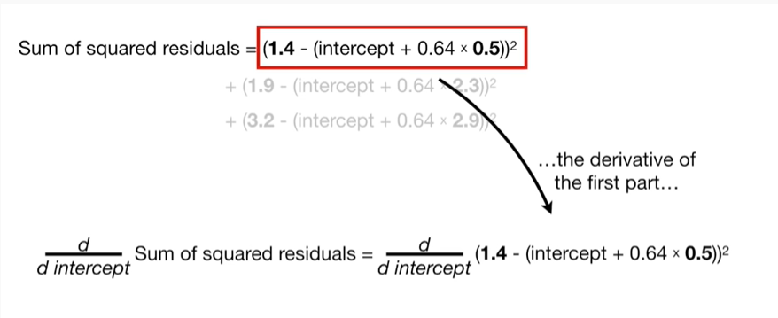the derivative of the first part

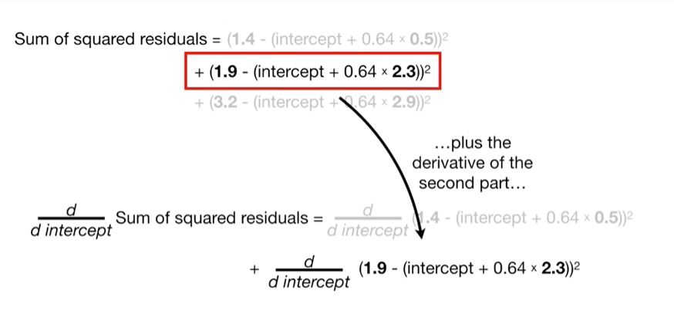

plus the derivative of the second part

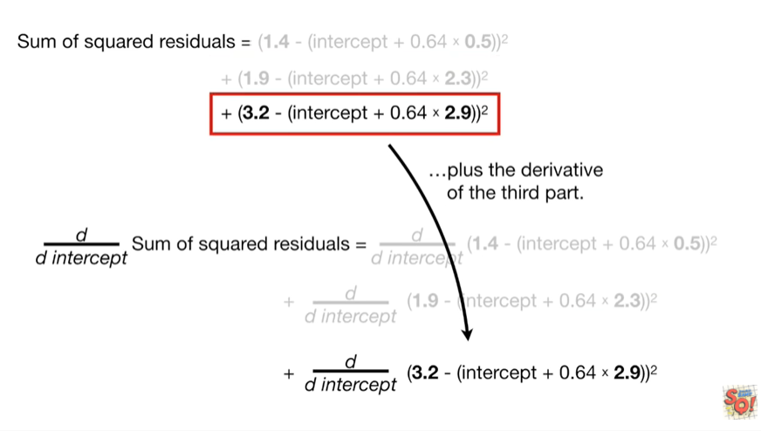

plus the derivative of the third part.

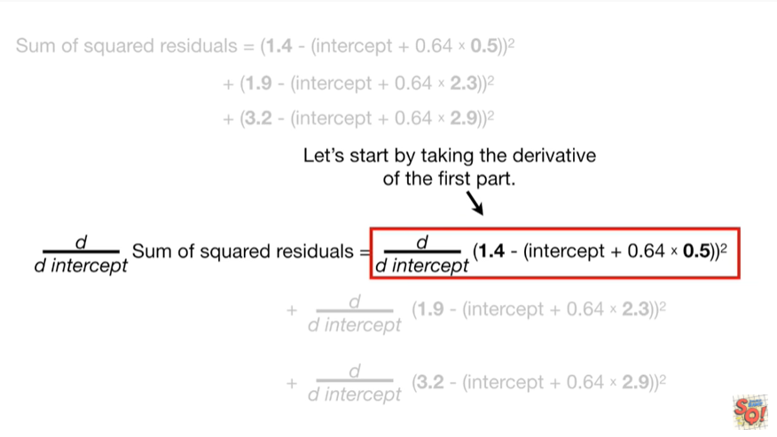

Let's start by taking the derivative of the first part.

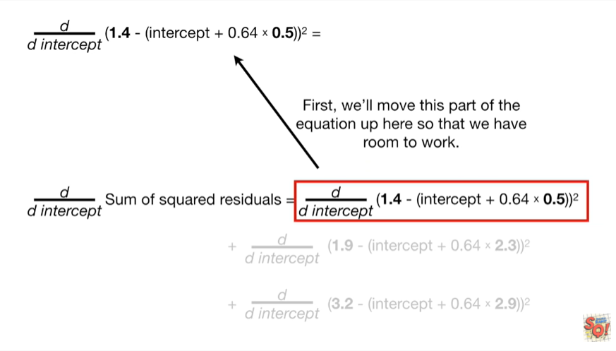

First, we'll move this part of the equation up here so that we have room to work.

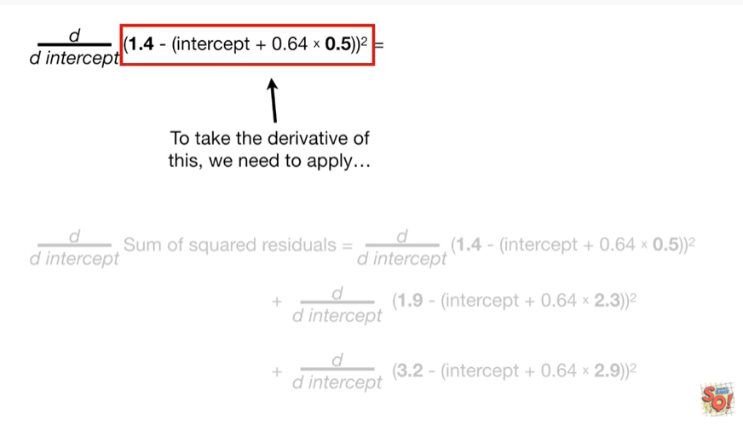

To take the derivative of this we need to apply



the chain rule.

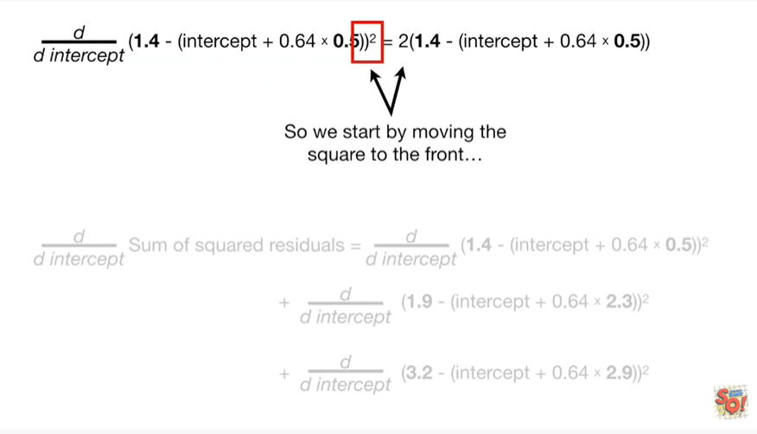

So we start by moving the square to the front

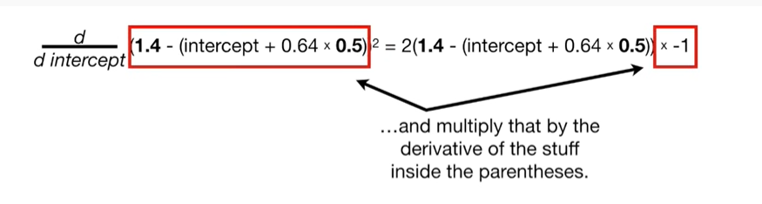

and multiply that by the derivative of the stuff inside the parenthesis

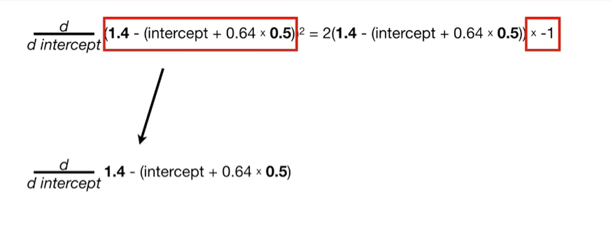

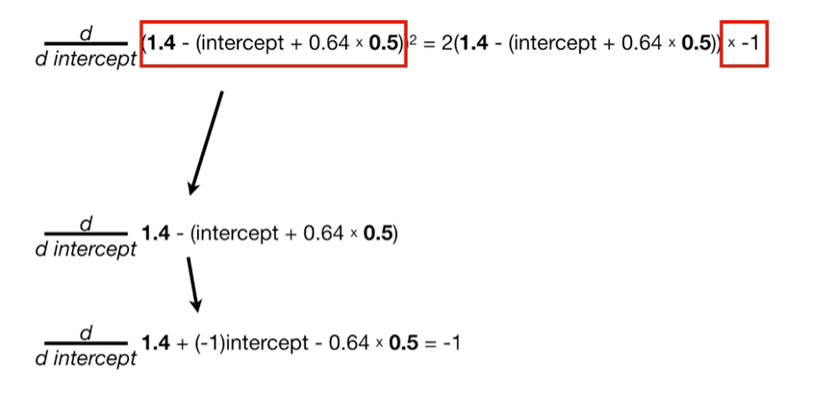

boo-boo-boo-boo-boo-boo-boop.

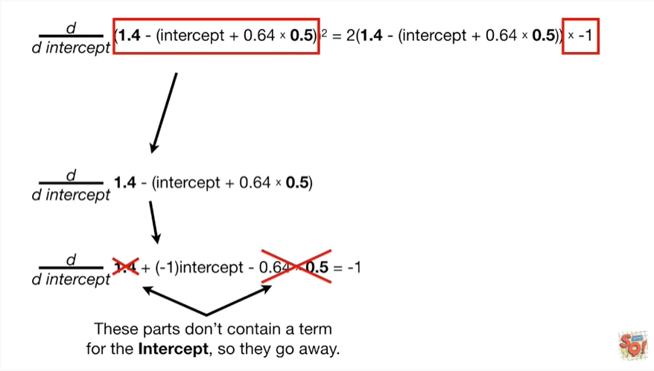

These parts don't contain a term for the intercept so they go away

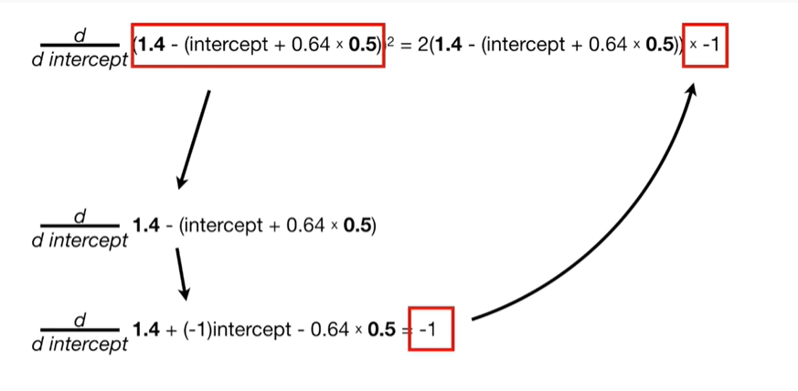

beep-boop

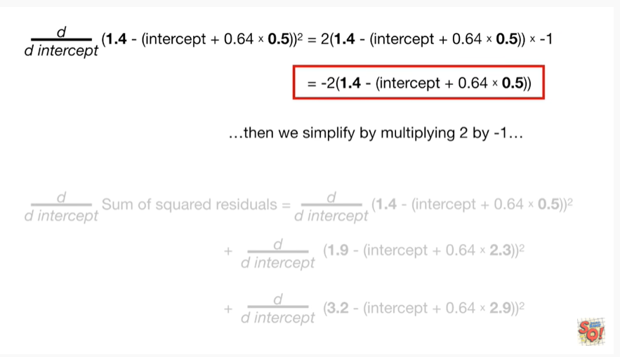

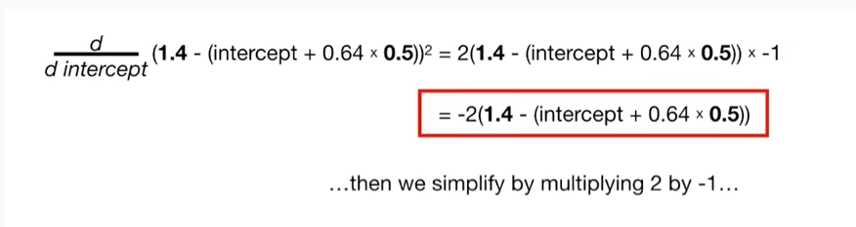

then we simplify by multiplying two by negative one

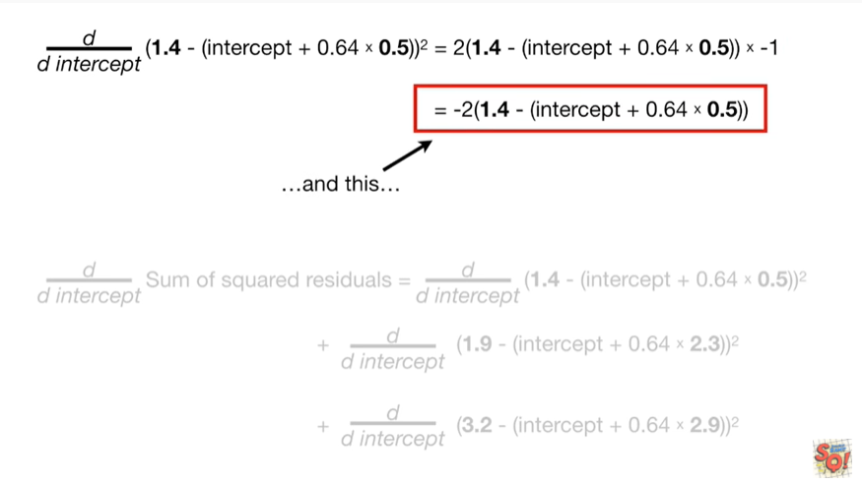

and this

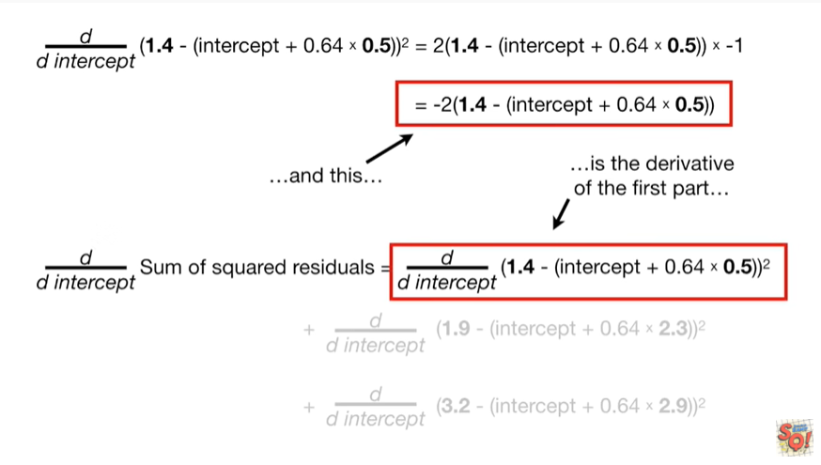

is the derivative of the first part

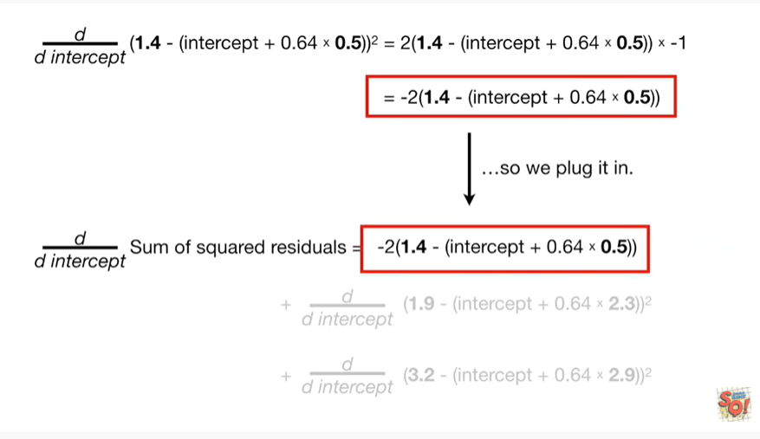

so we plug it in.

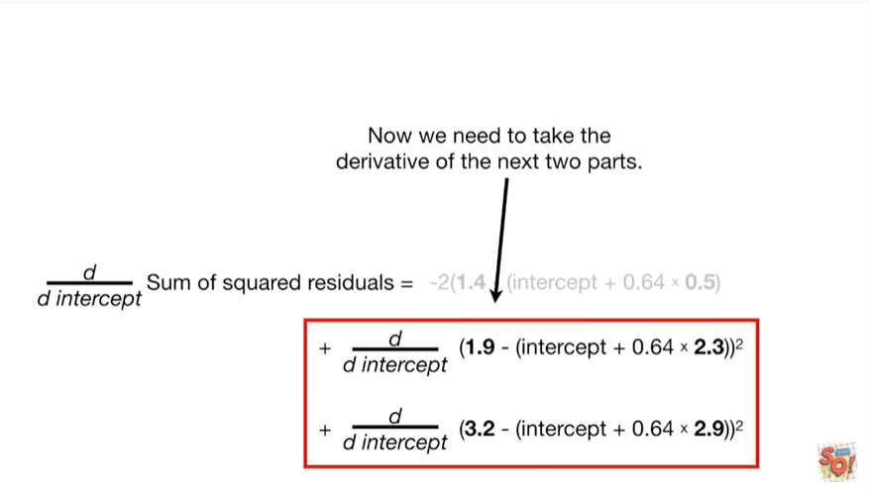

Now we need to take the derivative of the next two parts.

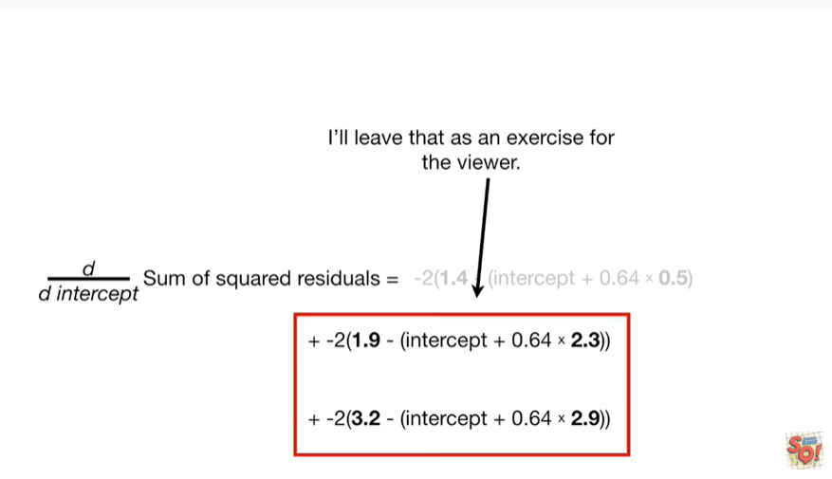

I'll leave that as an exercise for the viewer.

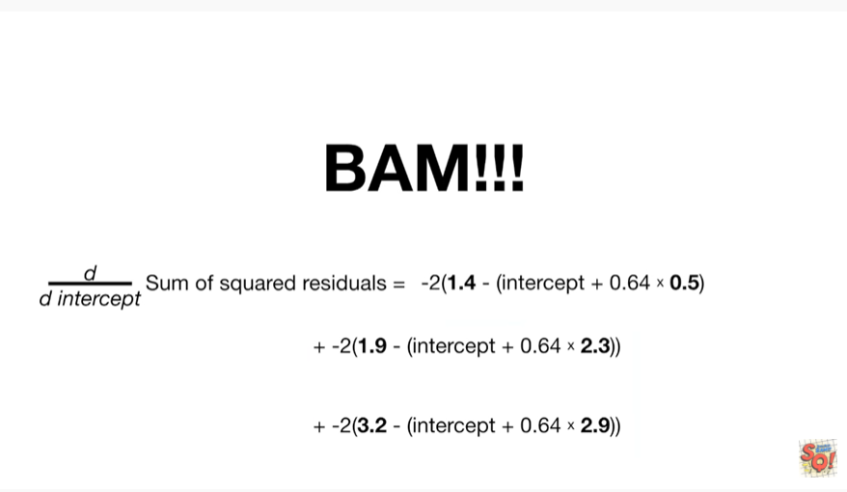

BAM !!!

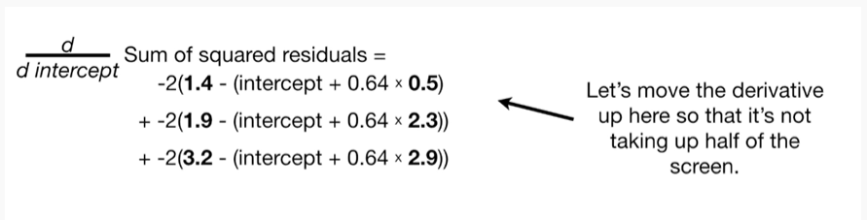

Let's move the derivative up here so that it's not taking up half the screen.

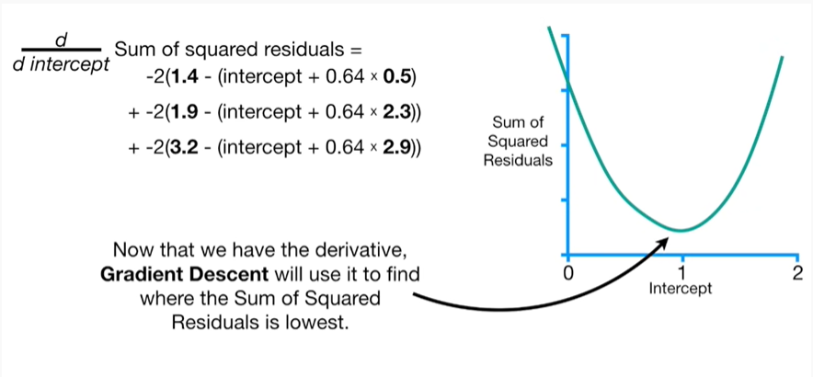

Now that we have the derivative gradient descent we'll use it to find where the sum of squared residuals is lowest.

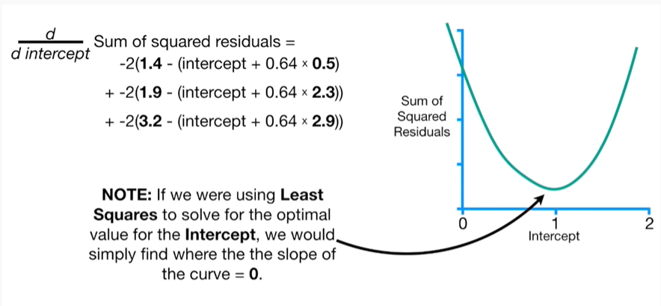

Note : if we were using least squares to solve for the optimal value for the intercept we would simply find where the slope of the curve equals zero.

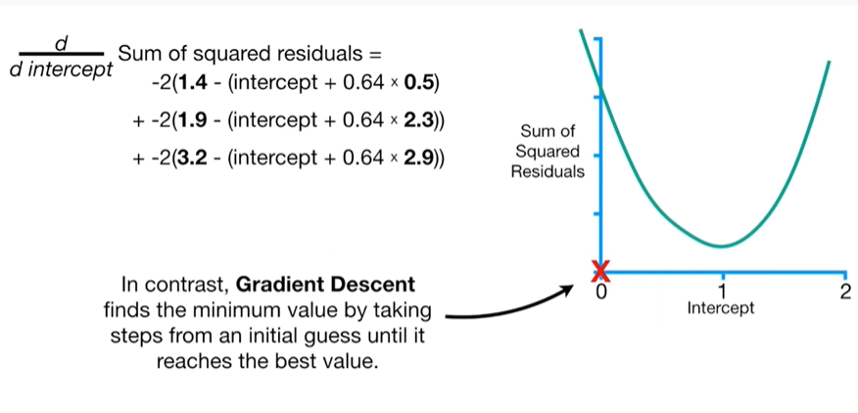

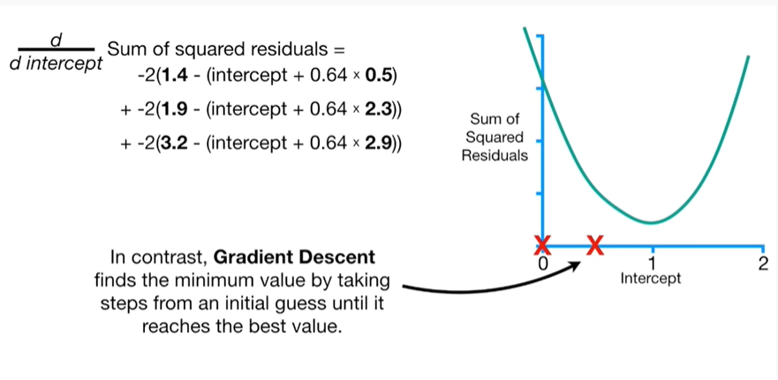

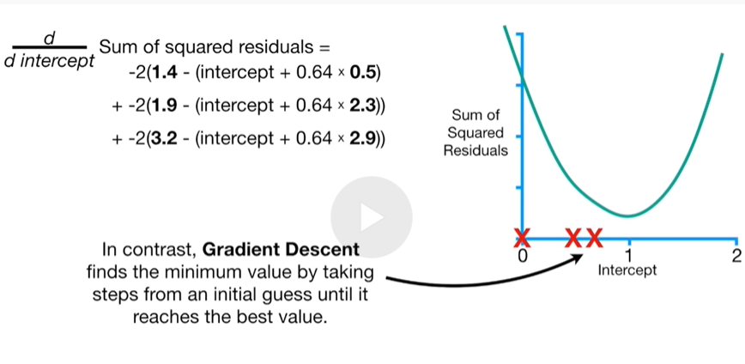

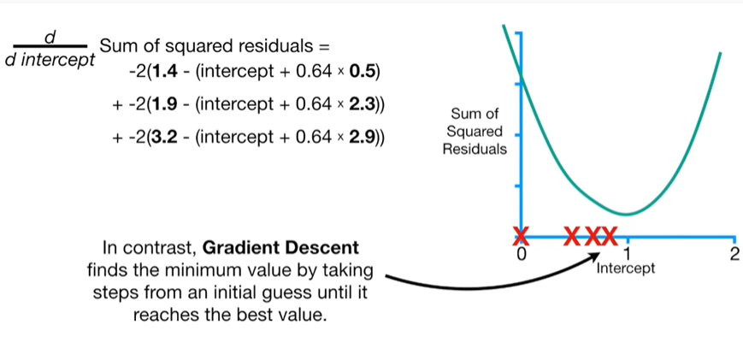

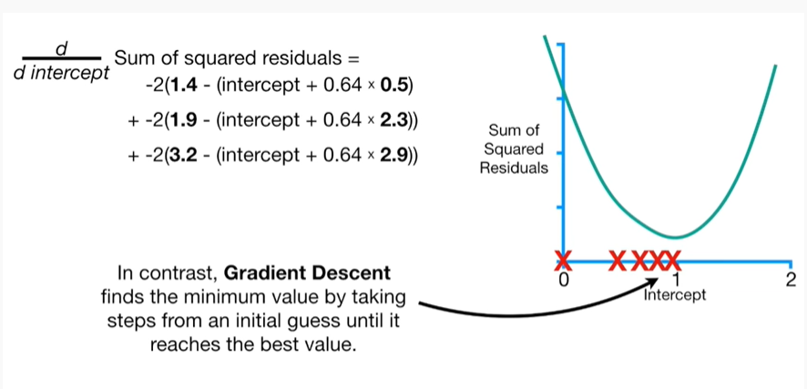

In contrast gradient descent finds the minimum value by taking steps from an initial guess until it reaches the best value.

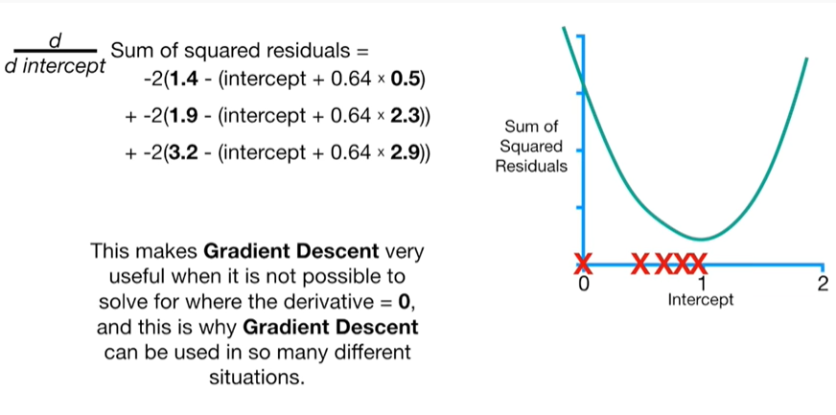

This makes gradient descent very useful when it is not possible to solve for where the derivative equals zero, and this is why gradient descent can be used in so many different situations.

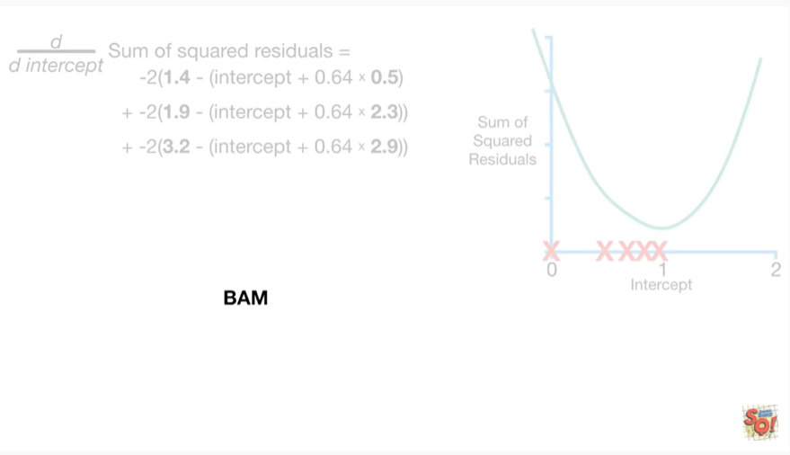

BAM !!!

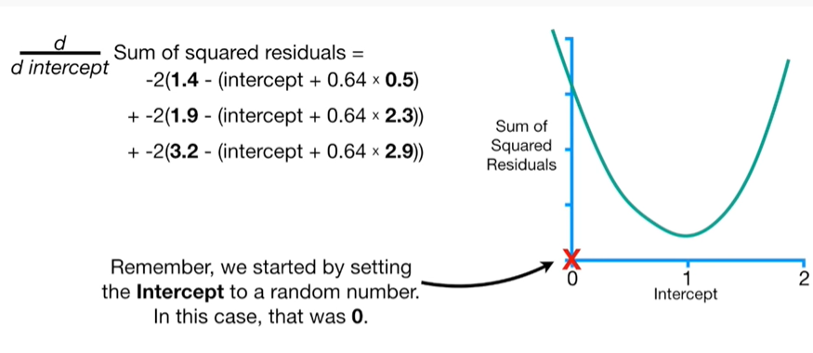

Remember, we started by setting the intercept to a random number.

In this case, that was zero.

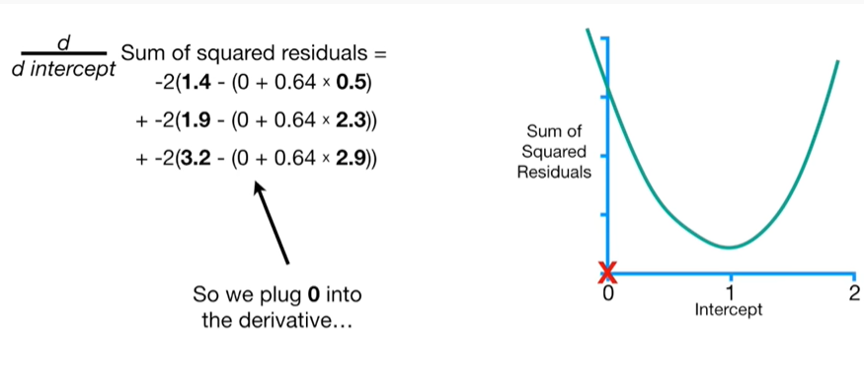

So we plug zero into the derivative

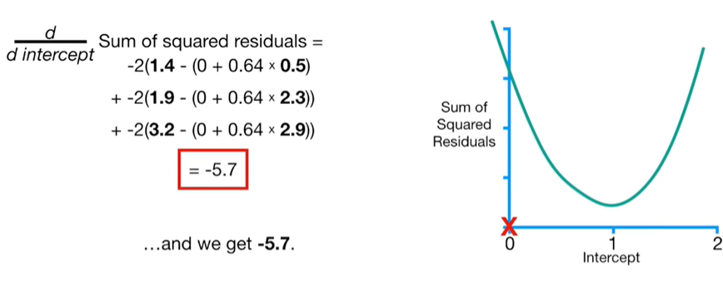

and we get negative five point seven.

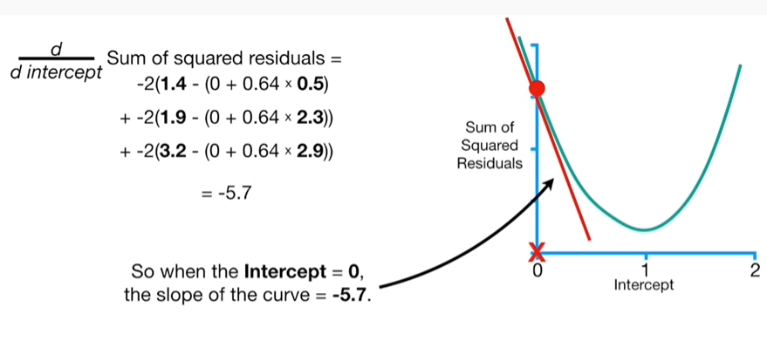

So when the intercept equals zero, the slope of the curve equals negative five point seven.

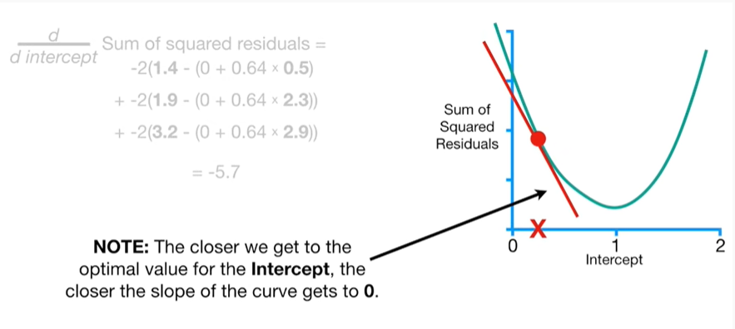

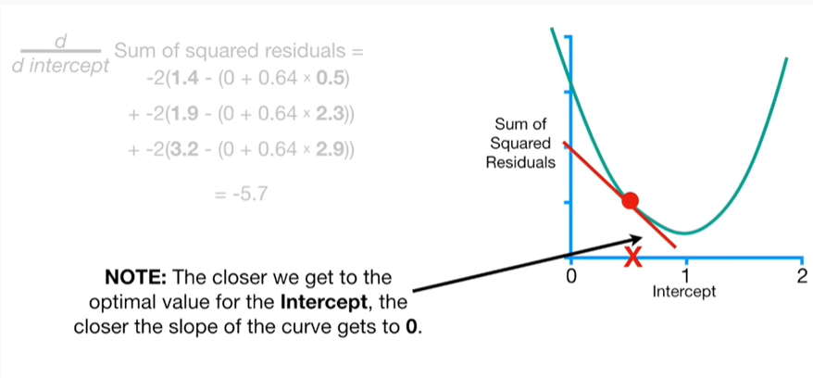

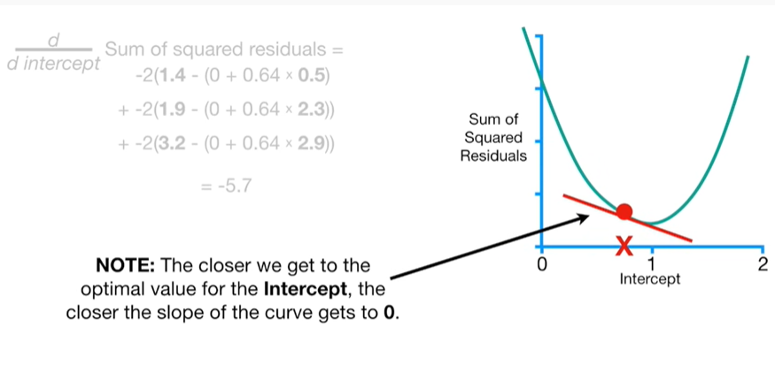

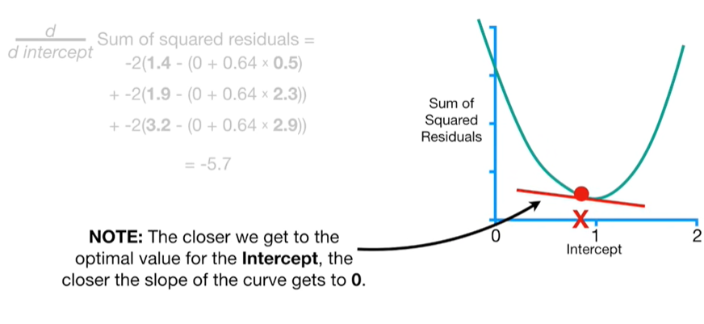

Note : the closer we get to the optimal value for the intercept, the closer the slope of the curve gets to zero.